Contents
Background 2
2021 consultation 2
Growing child safe organisations in Queensland — a timeline up to 2021 consultations 3
A summary of what we heard from consultations 4
What we heard: 5
Child safe standards 5
Standards for the Queensland context………………………………………………………..5
Scope……………………………………………………………………………………………..6
Oversight and regulation………………………………………………………………………..7
Organisational preparedness…………………………………………………………………10
Reportable conduct scheme 12
Scope……………………………………………………………………………………………12
Oversight and regulation………………………………………………………………………13
Organisational preparedness…………………………………………………………………14
Other issues raised 17
Blue Cards 17
Child and Youth Risk Management Strategy requirements 17
Next steps 17

Background
The Royal Commission into Institutional Responses to Child Sexual Abuse (Royal Commission) highlighted the devastating impacts of child sexual abuse and the significant role of organisational leadership and culture in growing safer environments for children, as well as the importance of independent oversight in the way institutions handle complaints about child sexual abuse. The Royal Commission developed 10 child safe standards as the blueprint for creating child safe organisations, aiming to minimise opportunities for harm to children and promote protective factors within organisations. It also recommended nationally consistent, independent oversight of institutions’ responses to complaints of child abuse through reportable conduct schemes. Both child safe standards and a reportable conduct scheme seek to improve organisational capability to keep children safe and ensure appropriate responses to allegations of child sexual abuse.

2021 consultation
A targeted consultation process commenced in March 2021. The consultation aimed to:
- raise awareness of child safe standards and reportable conduct schemes;
- seek feedback on the suitability of child safe standards in the Queensland context;
- help determine which organisations and sectors a reportable conduct scheme may apply to, and the appropriate scope of potential models of oversight of child safe standards;
- understand existing regulatory environments in different sectors and seek stakeholder views on options for oversight and regulation of child safe standards;
- consider organisations’ current self-assessed alignment with child safe standards; and
- understand what help organisations may need to implement child safe standards and comply with a reportable conduct scheme, and what transition period would be needed.
The targeted consultation process focused on peak bodies and other representative organisations in sectors identified for potential oversight and regulation by the Royal Commission.
A consultation paper, Growing Child Safe Organisations in Queensland, was sent to more than 170 stakeholders across more than 10 sectors in early March 2021. It sought feedback from stakeholders about options for the implementation and oversight of child safe standards and a Queensland reportable conduct scheme. It also asked stakeholders about how prepared they were to implement child safe standards and comply with a reportable conduct scheme, including what they would need to do in preparation and how much time they would need to comply.
Submissions in response to the consultation paper closed on 23 April 2021.
A series of information sessions was also held for key stakeholders. These were conducted between 12 and 26 March 2021 and focused on outlining the approach to consultation and providing an overview of work to implement child safe standards and a reportable conduct scheme in Queensland.
Targeted consultation snapshot
- 29 written submissions in response to the consultation paper were received from stakeholders from more than nine sectors, including education services for children, religious institutions, and sport and recreation groups.
- More than 60 people attended three information sessions.

Growing child safe organisations in Queensland — a timeline up to 2021 consultations

August 2015 | Royal Commission into Institutional Responses to Child Sexual Abuse released its Working With Children Checks report
April 2016 | The Council of Australian Governments, which included Queensland, agreed in-principle to harmonise reportable conduct schemes across jurisdictions, consistent with the NSW model.
March 2017 | Public consultation on a reportable conduct scheme commenced with the release of Queensland: A Reportable Conduct Scheme Issues Paper
July 2017 | Queensland Family and Child Commission released its report Keeping Queensland’s Children More than Safe: Review of the Blue Card System
December 2017 | Royal Commission into Institutional Responses to Child Sexual Abuse released its Final Report
June 2018 | Queensland Government tabled its response to the Royal Commission into Institutional Response to Child Sexual Abuse, accepting or accepting in principle all recommendations related to child safe standards and a reportable conduct scheme in Queensland
December 2018 | Queensland Government accepted the Royal Commission’s child safe standards as informing best practice for departments that provide services to children in its first annual progress report
February 2019 | Former Council of Australian Governments endorsed the National Principles for Child Safe Organisations
January 2021 | Queensland Government commenced two projects to identify options to a) support implementation of child safe standards in Queensland and b) establish a reportable conduct scheme
March 2021 | Targeted consultation on child safe standards and a reportable conduct scheme in Queensland commenced with the release of Growing Child Safe Organisations in Queensland: Consultation Paper and a series of information sessions
May 2021 | Targeted consultation on child safe standards and a reportable conduct scheme in Queensland concluded

A summary of what we heard from consultations
We heard strong support for the implementation of the child safe standards and a reportable conduct scheme in Queensland. Organisational readiness for implementation varied, but overall indicated a solid foundation to build on together to create safer organisations for children.
 | Scope | Regulation and oversight | Readiness for implementation
Child safe standards | We heard strong support for:  - Queensland’s standards being aligned with the National Principles for Child Safe Organisations.  - The scope of organisations covered by potential regulation in Queensland being consistent with the Royal Commission’s recommendations.  We heard considerable support for:  - Queensland’s standards addressing factors specific to the Queensland context, including human rights obligations and cultural safety for Aboriginal and Torres Strait Islander children.  - The scope of organisations covered by potential regulation in Queensland including organisations not included in the Royal Commission’s recommendations (e.g. all organisations that provide services to or impacting children; organisations that employ children). | There was strong support for:  - A regulatory system that mandates compliance.  - A staged approach to implementation, with an initial focus on awareness raising and capacity building before regulation and oversight.  - A responsive, risk-based approach to regulation.  We heard considerable support for:  - A co-regulatory approach that minimises duplication and regulatory burden.  - A supportive, rather than punitive, approach to promoting compliance.  There was limited support for:  - A voluntary compliance model of regulation.  - Peak bodies having oversight or regulatory responsibilities. | In terms of how ready stakeholders feel they are for implementing the child safe standards:  - 84% somewhat or very prepared to implement child safe standards; and  - 88% are able to implement child safe standards within two years.
Reportable conduct scheme | There was considerable support for:  - The scope of a Qld reportable conduct scheme being consistent with the Royal Commission’s recommendations. | We heard considerable support for:  - A separate reportable conduct scheme oversight body being aligned with existing bodies involved in the regulation and oversight of employee-related child protection matters.  - Sharing of information between the oversight body and existing regulatory frameworks (both national and state) to minimise duplication of obligations  - Advice and support (capacity building) being provided to organisations during implementation and ongoing operation of the scheme, targeting smaller or less regulated sectors. | In terms of readiness for implementing a reportable conduct scheme:  - 69% somewhat or very prepared to implement a reportable conduct scheme;  - 76% with mature or very mature complaints and investigative processes; and  - 73% able to implement a reportable conduct scheme within two years.

What we heard:
This part of the report summarises the key themes and broad feedback provided by stakeholders in our consultations.

Child safe standards

Standards for the Queensland context
Stakeholders provided broad, strong support for implementing the child safe standards in Queensland and gave insights into important guiding principles for a child safe organisations system.
Some stakeholders highlighted their support for an implementation approach for the child safe standards that moves beyond compliance, emphasising the benefits of outcomes-focussed principles and the importance of striving for excellence and best practice in child safe organisations.
Two stakeholders highlighted that implementation of the child safe standards should have an explicit focus on human/children’s rights, consistent with the United Nations Convention on the Rights of the Child (UNCRC) and the objects of the Human Rights Act 2019 (Qld). These stakeholders also noted the importance of supporting particularly vulnerable groups of children, including Aboriginal and Torres Strait Islander children, those who identify as LGBTQIA+, children from non-English speaking backgrounds, and others to make sure that the unique needs of these children are met.
In terms of whether the child safe standards are appropriate for the Queensland context as is, or whether there are other principles or elements that should be further considered, overall, stakeholders generally supported the child safe standards/National Principles without any changes, particularly noting that they:
- have been developed from extensive consultation, both on the part of the Royal Commission and from the National Children’s Commissioner and been subject to broad scrutiny in their development and implementation;
- are founded on a strong evidence base, informed by extensive research and broad consultation; and
- have an outcomes focus, are rights-based, child-centred and inclusive.
Some stakeholders indicated a preference for the National Principles over the Royal Commission’s child safe standards, noting the National Principles’ focus on children’s safety and wellbeing more broadly and their utility in promoting national consistency. Other stakeholders similarly indicated their support for national consistency.
Some stakeholders suggested changes to the child safe standards/National Principles, including:
- an explicit reference to human rights obligations;
- an increased focus on cultural safety;
- more clarity about key concepts; and
- standards/principles that are more tailored to different contexts.
A number of stakeholders suggested other amendments/improvements that are largely already reflected in the National Principles or Key Action Areas.

Scope

Organisations that should be subject to child safe standards
Stakeholders generally thought the types of organisations identified by the Royal Commission in recommendation 6.9 (Final Report) appropriately represented those that should be required to comply with child safe standards in Queensland, noting a broad approach is preferable to a narrow one.
Recommendation 6.9
Legislative requirements to comply with the Child Safe Standards should cover institutions that provide:
- accommodation and residential services for children, including overnight excursions or stays
- activities or services of any kind, under the auspices of a particular religious denomination or faith, through which adults have contact with children
- childcare or childminding services
- child protection services, including out-of-home care
- activities or services where clubs and associations have a significant membership of, or involvement by, children
- coaching or tuition services for children
- commercial services for children, including entertainment or party services, gym or play facilities, photography services, and talent or beauty competitions
- services for children with disability
- education services for children
- health services for children
- justice and detention services for children, including immigration detention facilities
- transport services for children, including school crossing services.

Some stakeholders nevertheless suggested that the Royal Commission’s recommended scope was not broad enough, and that it was important for other types of organisations to be captured by Queensland’s child safe standards. This particularly included:
- all organisations that provide services to, for or impacting children, regardless of their level of contact or involvement with children; and
- organisations that employ children and young people.
No stakeholder thought the Royal Commission’s recommended scope was too broad, although some highlighted the need for flexibility in how the child safe standards are applied within organisations, in recognition of the diversity of activities and services they deliver.
Some stakeholders also suggested more clarity was required about the types of organisations that would be captured within the Royal Commission’s broad categories. Specific queries included whether:
- training organisations for young adolescents are included in ‘education services for children’;
- children’s sporting groups are included in the clubs and associations category;
- universities should be included in ‘education services for children’ or a separate category for post-secondary education and training providers; and
- sub-contractors that provide services on an in-scope organisation’s behalf should also be subject to the child safe standards.

Subjecting some sectors to regulation and oversight before others (phased implementation)
There were mixed views about whether some sectors should be subject to regulation and oversight before others.
Some stakeholders were against a phased approach to implementation, noting concerns about inconsistency, confusion and risks to children with potentially adverse outcomes.
Other stakeholders supported a phased approach. Generally, these stakeholders identified the risks to children, organisational and sector capacity and a sector’s current level of regulation and oversight as the key factors to consider in determining which sectors should be prioritised.
However, there were differing views about how these factors should be assessed. That is, some stakeholders were in favour of prioritising sectors according to the level of risk to children inherent in the services they deliver, starting with the highest risk sectors. Others favoured prioritising sectors according to their current capacity and level of regulation and oversight. Most favoured starting with larger sectors and/or those that were funded or regulated by government, as in Victoria, although one stakeholder suggested starting with those organisations that were currently unregulated or under-regulated as these may pose a higher risk to children.

Oversight and regulation
Overall, stakeholders supported an approach to oversight and regulation that:
- leverages existing regulatory frameworks;
- aligns with current requirements; and
- features the oversight body collaborating with sector regulators to regulate the child safe standards, where there is an existing regulatory body.
Stakeholders emphasised that such an approach was particularly important for reducing regulatory burden, duplication and confusion, as well as strengthening implementation of the standards.
We also heard from some stakeholders about the risks of formal co-regulatory approaches, namely the risks of gaps and duplication in oversight, with a need to ensure co-regulators are sufficiently resourced and that there is thorough consideration of existing regulatory landscapes. Others also clarified their position that peak bodies should not have a compliance role in such a model.
Other views expressed by stakeholders about oversight and regulation of the child safe standards included:
- the need to balance consistency and flexibility in the way organisations are regulated, to accommodate the variable size and complexity of organisations and maximise regulatory efficiencies;
- that regulation must focus on creating child safe cultures, not tick-a-box compliance; and
- that consideration needs to be given to any unintended consequences of regulation.

Voluntary versus mandatory compliance
Most stakeholders were in favour of a mandatory compliance model for Queensland, consistent with recommendation 6.8 (Final Report) from the Royal Commission. Key reasons for this were as follows.
- Stakeholders agreed with the Royal Commission that ‘the implementation of mandatory child safe standards would make it clear that child safety in institutions that engage in child-related work is not optional and would thus drive cultural change’.
- Stakeholders thought a mandatory compliance model would be the most effective in protecting children, noting the risks of non-compliance with a voluntary model.
- Stakeholders thought a mandatory compliance model would ensure consistency in the application of child safe standards across different organisations and sectors.
- Stakeholders noted a mandatory compliance model would ensure Queensland’s implementation of child safe standards is consistent with practice in other jurisdictions.
‘A mandatory compliance model is preferable as it achieves consistency in the application of the standards across all sectors, increases the likelihood of creating a shared understanding of what a child safe organisation is and, in the longer term, achieves appropriate, positive cultural change across all relevant organisations.’ — Submission from a peak body in the education sector

Only one stakeholder expressed support for a voluntary compliance model. This stakeholder expressed concern that a mandatory compliance model would increase an already significant regulatory burden on organisations in the education sector.

Co-regulation – sharing regulatory responsibilities
One option under a mandatory compliance model is a co-regulatory approach. A co-regulatory approach may involve oversight of the standards being shared between existing regulatory bodies. An oversight body could also delegate some of its functions to sector regulators (e.g. school registration authorities or accreditation bodies) to take advantage of existing regulatory regimes.
Stakeholders identified sectors with existing regulatory mechanisms that may be suitable to co-regulate the child safe standards. Some sectors were the subject of mixed views about the relevance of existing regulatory bodies. This difference of views highlights the need for detailed mapping of existing regulatory landscapes in the design of any regulatory system.
Where there were sectors identified as lacking regulation (for example, children’s sporting teams, dance groups and religious institutions), there was strong support for regulation to be implemented.

A staged approach to implementation
Most stakeholders supported a staged approach to implementing child safe standards, focusing first on awareness raising and capacity building before imposing regulation and oversight. Stakeholders believe this would ensure organisations are properly prepared to implement the standards and giving organisations the best chance of meeting regulatory expectations.
Some stakeholders commented on what they saw as the key elements of capacity building under such an approach. These included:
- Taking an intelligence-led approach to capacity building activities and tailoring them to reflect an organisation’s/sector’s existing level of capacity.
- Developing comprehensive information and education resources, including self-assessment tools, template policies and procedures, and telephone helplines.
- Educating organisations with respect to culture, not just compliance, by focusing on the fundamental purpose of the standards.

Risk-based regulation – targeting monitoring and compliance activities
Many stakeholders expressed their support for a responsive, risk-based approach to regulation, with the oversight body identifying areas of highest risk and focusing resources on those areas. Proportionate, risk-based responses were identified by many stakeholders as an important feature in this type of regulatory model.
Stakeholders suggested areas of highest risk could be identified in various ways, including by reviewing and analysing data, requiring organisations to report publicly on their implementation of the child safe standards, liaising with key stakeholders, and assessing organisational risks using a situational approach.
We heard from two stakeholders who highlighted the need for the oversight body to engage with children and young people to appropriately target its monitoring and compliance activities.
One stakeholder noted there is also a need to bear in mind any pitfalls of a risk-based approach, including ensuring that areas of perceived lower risk are not neglected by the oversight body and that the focus is not just on known risks and on ‘repeat offender’ organisations.

Monitoring and compliance powers
Stakeholders supported oversight bodies adopting a supportive, rather than punitive, approach to promoting compliance with the child safe standards. This would include a focus on education and continual service improvement, helping organisations to learn from instances of non-compliance.
Stakeholders noted the importance of external compliance monitoring and were generally supportive of oversight bodies having a range of monitoring and enforcement powers consistent with those identified in the consultation paper (p. 15). Of these, stakeholders particularly noted their support for oversight bodies having the power to:
- request (and share) information;
- undertake audits (although one stakeholder expressed doubts about the utility of these);
- undertake own motion investigations;
- make recommendations;
- require or undertake public reporting, including maintaining a public register of non-compliant organisations (although two stakeholders noted some opposition or risks to this); and
- undertake enforcement actions, including issuing breach or compliance notices, applying financial penalties and instigating criminal or civil proceedings or court orders for serious failures (although one stakeholder noted some opposition to financial penalties).
Other powers or functions stakeholders suggested were important for oversight bodies to have included those to:
- receive complaints about organisations’ compliance with the child safe standards;
- consult with children and young people about organisations’ compliance with the child safe standards; and
- provide training, education and guidance to help organisations comply with the child safe standards.
Two stakeholders also highlighted the importance of internal compliance monitoring by organisations.
Stakeholders had mixed views about the appropriateness of using funding contracts in monitoring and enforcement of the child safe standards. Some stakeholders suggested the standards should be built into funding contracts, with the option to withdraw funding reserved for serious instances of non-compliance, while other stakeholders strongly opposed funding contracts being used as a compliance tool (given risks of inequity and ineffectiveness in achieving child safe cultural change).

Organisational preparedness

How prepared are organisations to implement the child safe standards
Most stakeholders said they were ‘somewhat’ or ‘very’ prepared to implement the child safe standards in their organisation or sector. This included in relation to education services for children; religious institutions; sporting and recreation groups; and health services for children. Many of these stakeholders noted they have been undertaking work that aligns with the child safe standards/National Principles for some time now.
How prepared is your organisation or sector to implement the child safe standards?
Somewhat or very prepared
84%
Unsure/varies
16%
Those stakeholders who felt somewhat or very prepared to implement the child safe standards noted the following indicators as demonstrating their progress towards being child safe:
- public commitments to child safety;
- leadership commitment to child safety;
- processes for incorporating children’s views into decision-making;
- existing policies, procedures and guidelines that are focused on child safety, including processes for responding to incidents and allegations of child abuse;
- child safe recruitment practices;
- training for staff;
- monitoring and oversight mechanisms; and
- review and continuous improvement mechanisms.
Some stakeholders noted that their sectors are diverse and that some organisations will be more prepared to implement the standards than others. Generally, there was a view that larger organisations and organisations that operate in jurisdictions where child safe standards are already in effect will be better prepared to implement the standards in Queensland.

What will organisations need to do?
Many stakeholders emphasised the need for education, awareness raising and capacity building, with many noting the oversight body and co-regulators will need to play a key role.
Stakeholders particularly highlighted the need for capacity building activities to feature:
- clear guidelines and expectations;
- training for staff across all levels of an organisation;
- access to online and other resources; and
- expert advice.
Some stakeholders who felt relatively well prepared to implement the child safe standards noted they would need to review their current practices, continue to monitor and evaluate their work, and look to continuously improve their approach to child safety and wellbeing.
Others noted that some organisations will need more support generally to become child safe, highlighting particularly that:
‘We believe that organisations are across the spectrum of preparedness, and it will be important in the design phase to understand the diverse needs of organisations in our industry.’ — Submission from an organisation in the community services sector
- Smaller organisations would likely need additional financial and human resources to implement the child safe standards.
- Cultural change will be important and should be supported.
- Organisations will need time.
- What organisations will need will depend on the standards that are adopted.

How much time will organisations need
Most stakeholders said they could implement the child safe standards within two years. This included many who said they were already compliant or would need no more than a year.
Only one stakeholder, in the education sector, said they would need more than two years to implement the standards.
Some stakeholders noted that the time they will need will ultimately depend on the nature of the model implemented in Queensland, including the specific child safe standards that are adopted and how these align with existing regulatory frameworks.
How much time would your organisation need to implement the child safe standards
(if you started today)?
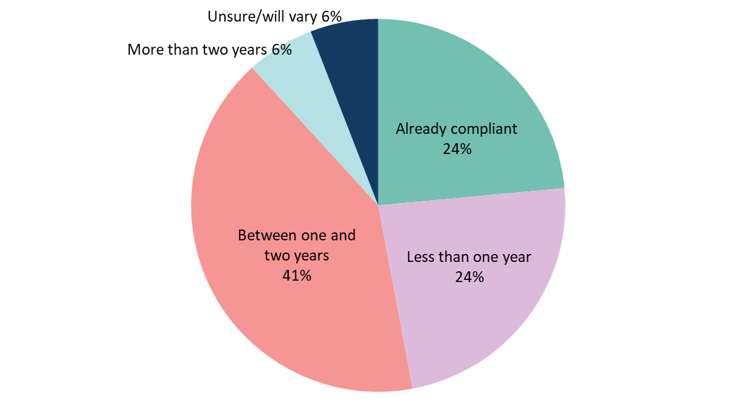

Reportable conduct scheme
Of the 29 submissions received, 17 responded to questions about the reportable conduct scheme, which focused on organisational readiness for the new obligations.

Scope
Only two stakeholders specifically commented on the types of organisations that should be within the scope of a Queensland reportable conduct scheme. They generally supported the scope of a Queensland scheme being consistent the with recommendation 7.12 (Final Report).
Recommendation 7.12
Reportable conduct schemes should cover institutions that:
- exercise a high degree of responsibility for children; and
- engage in activities that involve a heightened risk of child sexual abuse, due to institutional characteristics, the nature of the activities involving children, or the additional vulnerability of the children the institution engages with.
At a minimum, these should include institutions that provide:
- accommodation and residential services for children, including.
- housing or homelessness services that provide overnight beds for children and young people
- providers of overnight camps
- activities or services of any kind, under the auspices of a particular religious denomination or faith, through which adults have contact with children
- childcare services, including
- approved education and care services under the Education and Care Services National Law
- approved occasional care services
- child protection services and out-of-home care, including
- child protection authorities and agencies
- providers of foster care, kinship or relative care
- providers of family group homes
- providers of residential care
- disability services and supports for children with disability, including
- disability service providers under state and territory legislation
- registered providers of supports under the National Disability Insurance Scheme
- education services for children, including
- government and non-government schools
- TAFEs and other institutions registered to provide senior secondary education or training, courses for overseas students or student exchange programs
- health services for children, including
- government health departments and agencies, and statutory corporations
- public and private hospitals
- providers of mental health and drug or alcohol treatment services that have inpatient beds for children and young people
- justice and detention services for children, including
- youth detention centres
- immigration detention facilities.

Oversight and regulation

Existing oversight bodies and how their functions could align with a reportable conduct scheme
Stakeholders identified existing bodies that play a role in regulation and oversight of the handling of employee-related child protection matters:
- across multiple sectors – including the Queensland Police Service (QPS) and Blue Card Services in the Department of Justice and Attorney-General; and
- in particular sectors – including government funders, disciplinary/professional standards bodies and professional registration /accreditation bodies — for example, the Queensland College of Teachers and the Non-State Schools Accreditation Board in the education sector; the Australian Health Practitioners Regulation Agency (AHPRA) and the Office of the Health Ombudsman in the health sector; and the National Disability Insurance Scheme (NDIS) Quality and Safeguards Commission in the disability services sector.
Stakeholders generally supported that the functions of these existing bodies could be aligned with a central oversight body for a reportable conduct scheme, as a way of both minimising duplication and providing the opportunity for a central oversight body to address existing gaps in regulation. For example, stakeholders in the education sector noted that a separate body for a reportable conduct scheme could provide oversight of non-teacher employees, who are not captured under the functions of the Queensland College of Teachers.
Stakeholders noted that the scope of a reportable conduct scheme and relevant processes will need to be very clear to ensure these aims are met.
Some stakeholders expressed views about who would be an appropriate central oversight body. Suggestions included the Queensland Ombudsman, the Queensland Family and Child Commission (QFCC) or a new independent body.

Functions of an independent oversight body
One stakeholder in the justice and legal sector expressed the view that an independent oversight body for a reportable conduct scheme should have a broad capacity to conduct its own investigations and receive complaints directly from children.
This stakeholder and others also expressed their support for the oversight body being a source of expert information and advice for organisations, including about how to conduct effective investigations and about the nature of child sexual abuse and how to prevent it.
Providing independent oversight of how certain organisations prevent and handle allegations and convictions of child abuse by the organisation’s staff… is a necessary but not sufficient role for the scheme to play. There is also an important role to play as a source of expertise and advice for institutions on how to better identify and manage risks to children; and encourage better internal complaint handling. — Submission from an organisation in the justice/legal sector
The oversight body should be a source of information and advice on how to conduct an investigation and the type of evidence that needs to be collected, what needs to be done to preserve evidence, and techniques and procedures to afford fairness and to avoid traumatising or retriggering trauma for the child and, in the circumstances of complaints by Aboriginal or Torres Strait Islander children, how to ensure that an investigation is conducted in a culturally competent manner. — Submission from an organisation in the justice/legal sector

Organisational preparedness

How prepared are organisations
Most stakeholders said they were ‘somewhat’ or ‘very’ prepared to implement a reportable conduct scheme in their organisation or sector. This included in relation to education services for children; child protection services, including out-of-home care; religious institutions; and health services for children. Many of these stakeholders noted they had existing obligations and practices for responding to concerning conduct by staff that contributed to them feeling prepared to implement a reportable conduct scheme.
One stakeholder in the education sector did note, however, that their sector is diverse, and that some institutions will therefore be more prepared than others. Similar comments were made by a stakeholder in the community services sector.
Two stakeholders, both in the sport and recreation sector, said they were somewhat unprepared to implement a reportable conduct scheme. This reflected a) the large number of autonomous organisations in their sector and b) limited resourcing.
‘Whilst we have a robust process for receiving allegations and reporting to authorities, we do not have the resourcing that would be required through creation of the proposed scheme… [The nature of the proposed scheme] is likely to require [the organisation] to engage a legal professional to conduct investigations which will require substantial diversion of program funding to meet high employment costs.’ — Submission from an organisation in the sport and recreation sector
How prepared is your organisation or sector to implement a reportable conduct scheme?

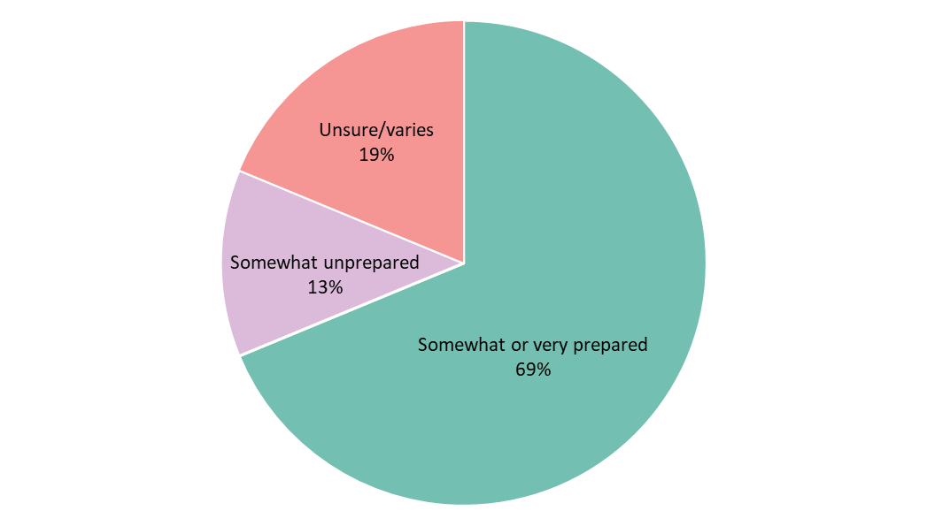

How mature are existing processes
Most stakeholders said their organisation or sector’s processes for responding to allegations of employee or volunteer conduct that raises child protection concerns were ‘somewhat’ or ‘very’ mature. Again, many stakeholders noted their existing processes for responding to concerning conduct. It is noted this finding aligns with similar questions regarding organisational readiness for the child safe standards.
How mature are your organisation or sector’s complaints and investigative processes for responding to allegations of employee or volunteer conduct that raises child protection concerns?
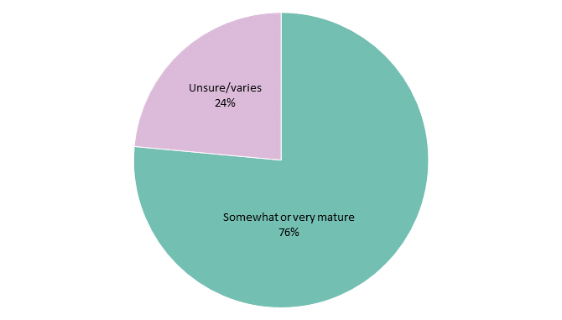

What will organisations need to do
To implement and comply with a reportable conduct scheme, stakeholders highlighted the need to:
- train and educate staff, including service delivery staff, program/policy staff and governance/compliance/legal staff;
- access online and other resources that can provide advice about requirements; and
- engage or seek advice from experts.
This is consistent with the options outlined in the consultation paper.
A number of stakeholders said they would also need to develop new processes and resources or review and update their existing policies, procedures, guidelines and training to ensure they met the requirements. One stakeholder highlighted that for their sector, implementation would need to be supported by both overarching statewide policies and local resources.
A few stakeholders indicated their expectations of an increase in expenditure to implement a reportable conduct scheme and that they would need additional funding and resources, noting that current funding arrangements would not accommodate the anticipated impacts.
Finally, two stakeholders emphasised the need for the community to be consulted about the development and implementation of a Queensland reportable conduct scheme.
‘[The organisation] does, however, highlight the need for extensive community consultation with Aboriginal and Torres Strait Islander communities and would appreciate the opportunity to engage further to ensure cultural perspectives are considered.’ — Submission from a peak body in the education sector
‘[The organisation] recommends that a thorough public consultation process be undertaken on the form, structure and implementation of… a reportable conduct scheme to ensure an effective child safe organisations framework is established for Queensland.’ — Submission from an oversight body operating in multiple sectors

How much time will organisations need
Most stakeholders indicated they would need no more than 18 months to develop the policies, procedures and training necessary to implement a reportable conduct scheme. In most instances, these stakeholders said they would be ready within 12 months or less.
Only two stakeholders, one in the education sector and one in the community services sector, indicated they may need more than 18 months to implement a reportable conduct scheme.
Several other stakeholders indicated that the time they will need will ultimately depend on the specific model that is implemented.
How much time would your organisation or sector need to develop policies and procedures that support a reportable conduct scheme?
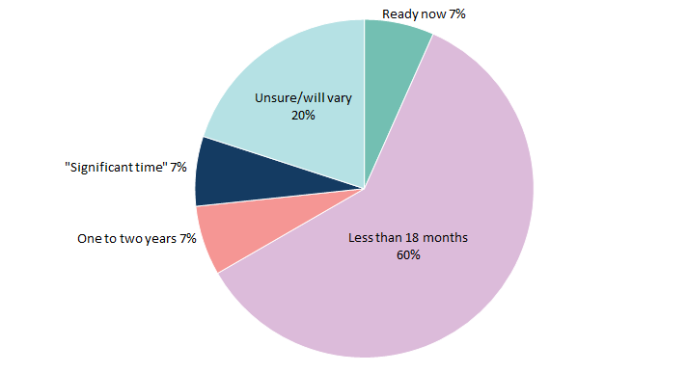
Overall, responses regarding the reportable conduct scheme varied within sectors. However, the education, health and child protection sectors generally reported greater confidence of preparedness and maturity, while some community services and clubs/sport and recreation organisations reported less confidence or more variation within their sectors.

Other issues raised

Blue Cards
Several stakeholders raised concerns about existing Blue Card requirements, including in relation to inter-jurisdictional operation, information sharing, and overall effectiveness.

Child and Youth Risk Management Strategy requirements
Three stakeholders expressed support for the existing Child and Youth Risk Management Strategy requirements in the Blue Card legislation being considered and revised as part of the implementation of the child safe standards/National Principles.

Next steps
The feedback from the consultation is directly informing our work in developing options for how Queensland could implement the child safe standards and a nationally consistent reportable conduct scheme. There will be further opportunities to have your say and we will continue to ensure we partner with a broad range of sectors working with children as part of this process.

