**Protecting your privacy**

To do its job, the Department of Families, Seniors, Disability Services and Child Safety (the department) collects information about people it works with.

This includes information about you.

There is a law (the [*Information Privacy Act 2009*](https://www.bing.com/ck/a?!&&p=c6d87159bcb2df36JmltdHM9MTcxNzg5MTIwMCZpZ3VpZD0wMGVhYzRkMy03ZjViLTYyMTQtMmRlOS1kNmIwN2VjYjYzMWMmaW5zaWQ9NTIxMA&ptn=3&ver=2&hsh=3&fclid=00eac4d3-7f5b-6214-2de9-d6b07ecb631c&psq=informationm+privacy+act+2009&u=a1aHR0cHM6Ly93d3cubGVnaXNsYXRpb24ucWxkLmdvdi5hdS92aWV3L3BkZi9pbmZvcmNlL2N1cnJlbnQvYWN0LTIwMDktMDE0&ntb=1)) that says how the department must treat your information.

**What does thismean for you?**

**Collecting your information**

When it collects information about you, the department must:

* only collect information that they need
* collect the information fairly and legally
* tell you:
  + why it is asking you for information
  + why it is allowed to ask for your information
  + how it will use your information
  + who may get your information
* only collect information about you that it needs and is up to date
* collect your information in a way that respects your privacy.

**Security**



The department must keep your information safe.

**How can you ask for a copy of your information or change it?**

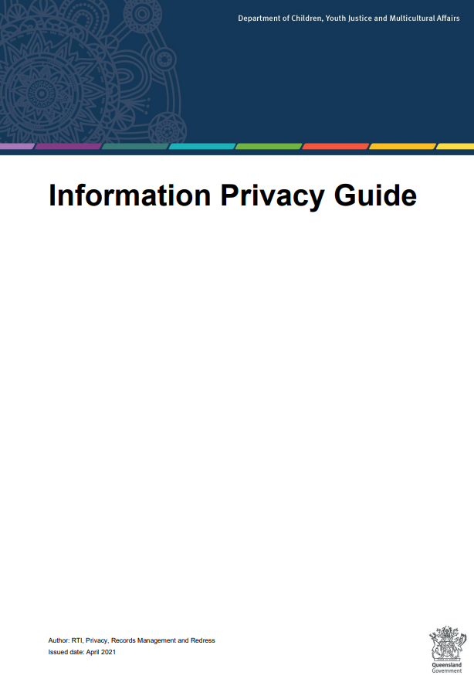

The department has a [Privacy Policy](https://www.dcssds.qld.gov.au/resources/dcsyw/about-us/right-to-information/privacy-guide.pdf) on its website.

It tells you what types of information it collects.

**Contact the RTI team**

The RTI team is the ‘Right to Information’ team.

They will help you:

* if you want a copy of the information the department has about you
* if you think the information is wrong or not up to date.

You might have to fill out a form.



Phone: 1800 809 078 (Free call) or (07) 3097 5605



Email: [rti@dcssds.qld.gov.au](mailto:rti@dcssds.qld.gov.au)

**Who gets your information?**

The department must make sure that:

* they only use correct information
* they only use your information how they said they would
* they do not give your information to anyone else.

There are reasons why the department may need to use or share your information.

Some reasons are:

* when you agree to it
* when there is a safety risk to you or others
* when the law says they can do it.



**Complaints**

If you think the department has done the wrong thing with your information, you can make a privacy complaint.

You can talk to the Complaints team or email them, and they will help you.

**Contact the Complaints Team**

* Phone: 1800 080 464
* 
* Email: [feedback@dcssds.qld.gov.au](mailto:feedback@dcssds.qld.gov.au)