Protecting your privacy
To do its job, the Department of Families, Seniors, Disability Services and Child Safety (the department) collects information about people it works with. This includes information about you.
There is a law (the Information Privacy Act 2009) that says how the department must treat your information.

What does this mean for you?

Collecting your information
When it collects information about you, the department must:
- only collect information that they need
- collect the information fairly and legally
- tell you:
  - why it is asking you for information
  - why it is allowed to ask for your information
  - how it will use your information
  - who may get your information
- only collect information about you that it needs and is up to date
- collect your information in a way that respects your privacy.

Security
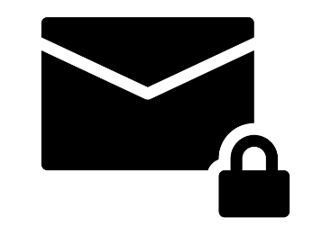

The department must keep your information safe.

How can you ask for a copy of your information or change it?
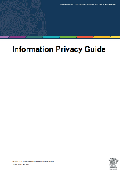
The department has a Privacy Policy on its website.
It tells you what types of information the department collects.

Contact the RTI team
The RTI team is the ‘Right to Information’ team.

They will help you:

- if you want a copy of the information the department has about you

- if you think the information is wrong or not up to date.

You might have to fill out a form.
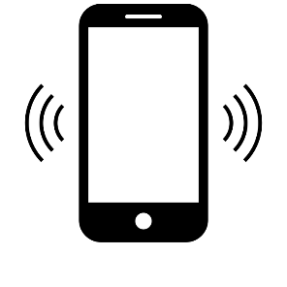
Phone: 1800 809 078 (Free call) or (07) 3097 5605


Email: rti@families.qld.gov.au

Who gets your information?
The department must make sure that:
- they only use correct information

- they only use your information how they said they would

- they do not give your information to anyone else.

There are reasons why the department may need to use or share your information. Some reasons are:
- when you agree to it
- when there is a safety risk to you or others
- when the law says they can do it.


Complaints

If you think the department has done the wrong thing with your information, you can make a privacy complaint. You can talk to the Complaints team or email them, and they will help you.
Contact the Complaints Team
Phone: 1800 080 464

Email: feedback@families.qld.gov.au

