

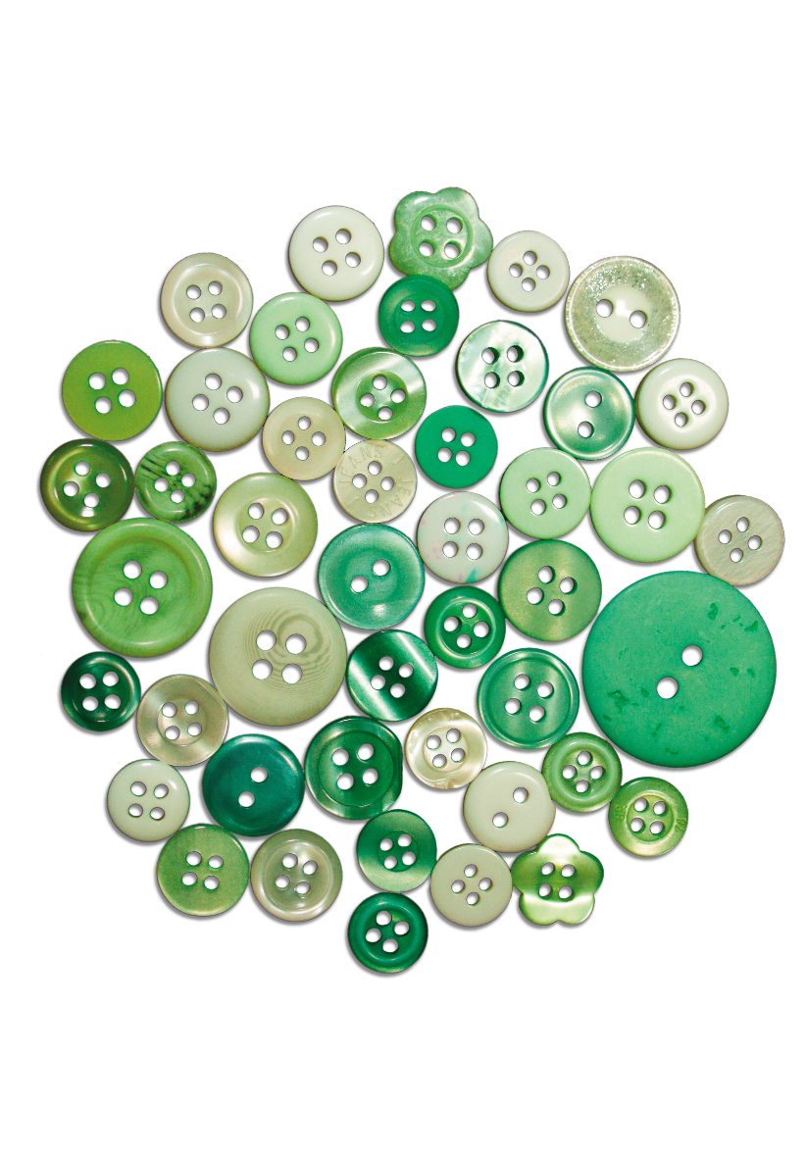

|  |
| --- |
|  |
|  |

|  |
| --- |
| Queensland Carers – Social Return and Investment  Department of Families, Seniors, Disability Services and Child Safety  17th April 2025 |

Contents

Glossary i

Executive summary ii

Key findings: iii

Conclusions and implications: iv

1 Carers in Queensland 5

1.1 What is an informal carer? 5

1.2 Demographic profile of informal carers in Queensland 6

1.2.1 Gender and age 7

1.2.2 Characteristics of care provided 9

1.2.3 Employment and income 11

1.2.4 Diversity 14

1.2.5 Location 15

1.2.6 Demographics of care recipients 15

2 Economic value of informal care in Queensland 18

2.1 Replacement cost valuation 18

2.1.1 Methodology and data 19

2.1.2 Discussion 19

2.1.3 Sensitivity analysis 20

3 Services for Carers in Queensland 22

3.1 Current services for carers in Queensland 22

3.2 Carer needs and identification of service gaps 24

3.3 Cost estimate to fill the carer support service gap 25

3.4 Methodology 25

3.5 Discussion 27

4 Demand and supply projections for carers 29

4.1 Individuals requiring care 29

4.2 Informal carer requirement 29

4.3 Results 30

4.4 Discussion 31

4.4.1 Population and demographic trends 31

4.4.2 Prevalence and intensity of profound or severe disabilities 31

4.4.3 Size and scope of the formal care sector 32

4.4.4 Social and economic factors impacting the hours of care a carer can provide 32

4.5 Policy implications 33

4.5.1 Health and social services sector 33

4.5.2 Labour market, economic and fiscal outcomes 33

4.5.3 Support for carers 33

Appendix A: Replacement cost valuation methodology 34

Total hours of care 34

Wage estimate 35

Results 36

Appendix B: Service gap costing methodology 37

Unit cost of Carer Gateway services 37

Appendix C: Unmet service needs for carers 39

Appendix D: Accessibility tables 41

Chapter 1 41

Limitation of our work 45

General use restriction 45

Charts

Chart 1.1: Informal carer share of population, by jurisdiction, 2022 6

Chart 1.2: Growth in the number of carers and demand for care, 2015-2022 7

Chart 1.3: Number of informal carers by carer type and gender, 2022 7

Chart 1.4: Age distribution of informal carers by carer type, 2022 8

Chart 1.5: Age distribution of informal carers by gender, 2022 8

Chart 1.6: Age distribution of informal carers over time, 2009-2022 9

Chart 1.7: Average hours of care provided per week by carer type, 2022 9

Chart 1.8: Average hours of care provided per week by gender, 2022 10

Chart 1.9: Average hours of care provided per week by disability status, 2022 10

Chart 1.10: Number of care recipients, 2022 11

Chart 1.11: Employment status of informal carers by carer type, 2022 12

Chart 1.12: Participation rate of informal carers over time, 2015-2022 13

Chart 1.13: Income distribution by carer type, 2022 13

Chart 1.14: Main source of income by carer type, 2022 14

Chart 1.15: Migrant status by carer type, 2022 15

Chart 1.16: Informal carer share of population by remoteness level, 2022 15

Chart 1.17: Age and gender of main care recipient, 2022 16

Chart 1.18: Disability status of main care recipients, 2022 16

Chart 1.19: Relationship of primary carers to their main recipient of care, 2022 17

Chart 4.2: Projected number of people requiring care and the associated primary carer requirement in Queensland, 000s people 30

Tables

Table 2.1: Replacement valuation of informal care, unit cost component 19

Table 2.2: Replacement valuation of informal care, SCHADS award wage 20

Table 2.3: Sensitivity analysis for the average hours of non-primary and non-secondary care on the total replacement value 21

Table 3.1: Current services available to informal carers in Queensland 23

Table 3.2: Unmet needs for informal carers 24

Table 3.3: Unmet needs for informal carers by demographic characteristics 25

Table 3.4: Unit costs of carer services 26

Table 3.5: Cost to provide one additional unit of support for carers indicating an unmet need 27

Table 4.2: Projected number and growth of individuals requiring care and carer requirement in Queensland 31

Table A.1: Average hours of care provided per week for primary and secondary carers 34

Table A.2: Distribution of weekly hours of care by carer type 34

Table A.3 Total hours of care provided by carer type 35

Table A.4: Replacement valuation of informal care, unit cost component 36

Table B.1: Number of services provided by Carer Gateway, 2022 37

Table B.2: Cost to provide one additional unit of support for carers indicating an unmet need 38

Table C.1: Detailed unmet needs for informal carers by demographic characteristics 39

Table D.1: Growth in the number of carers and demand for care, 2015-2022 – Chart 1.2 41

Table D.2: Age distribution of informal carers over time, 2009-2022 – Chart 1.6 41

Table D.3: Average hours of care provided per week by disability status, 2022 – Chart 1.9 42

Table D.4: Employment status of informal carers by carer type, 2022 – Chart 1.11 42

Table D.5: Participation rate of informal carers over time, 2015-2022 – Chart 1.12 42

Table D.6: Income distribution by carer type, 2022 – Chart 1.13 43

Table D.7: Main source of income by carer type, 2022 – Chart 1.14 43

Table D.8: Age and gender of main care recipient, 2022 – Chart 1.17 43

Table D.9: Disability status of main care recipients, 2022 – Chart 1.18 43

Table D.10: Relationship of primary carers to their main recipient of care, 2022 – Chart 1.19 44

Glossary

|  |  |
| --- | --- |
| ABS | Australian Bureau of Statistics |
| ANZSCO | Australian and New Zealand Standard Classification of Occupations |
| GDP | Gross Domestic Product |
| NCS | National Carer Survey |
| NDIS | National Disability Insurance Scheme |
| SCHADS | Social, Community, Home Care and Disability Service Industry |
| SDAC | Survey of Disability, Ageing and Carers |
| UNSW | University of New South Wales |

1. Executive summary

Unpaid informal carers play a critical role in society and the economy. The care they provide ranges from significant to critical to the lives of the individuals they care for, their families, and the broader community. However, their value is largely unrecognised by government, the community, and the economy. Their time and value are not captured in formal economic measures like Gross Domestic Product (GDP) or labour statistics such as employment and hours worked, despite their critical role in reducing the pressure on the formal care sector, which is already facing acute skills shortages, and increasing and unsustainable costs.

For the person providing care the caring role can be rewarding and fulfilling. At the same time, the caring role often comes at an economic, physical, mental and social cost to the carer, impacting their ability to participate in the formal labour market, training and education, and other activities such as exercise, leisure and socialising. Carers are three times more likely to report high levels of loneliness compared to other Australians, while two-thirds of Australian carers experienced a reduction in earned income upon becoming a carer.

Acknowledging the economic value of informal carers is a critical step towards recognising their important role in the economy, supporting them with their caring role, enabling greater economic participation and improving their quality of life. Greater recognition and awareness of carer demographics, support needs and preferences helps to build the evidence base to support social policy, ensuring the needs of carers and care recipients are appropriately recognised by policymakers in both federal and state governments.

To this end, Deloitte Access Economics has been engaged by the Department of Families, Seniors, Disability Services and Child Safety (DFSDSCS) to support development of a robust evidence base on informal carers in Queensland to inform future advice to government regarding carer supports and services that sustain the carer role. This report includes the following sections:

* **Carers in Queensland:** A demographic profile of carers in Queensland has been developed, providing an overview of primary and non-primary carers by gender, age, employment status and other relevant demographic characteristics.
* **Services for Carers in Queensland:** Desktop research was conducted to identify services available for carers in Queensland. Services have been tabulated by service type, location, funding source, and eligibility. Carer needs and service gaps have also been identified alongside an illustration of what it may cost to provide additional services to informal carers in Queensland.
* **Economic value of informal care in Queensland:** A replacement cost methodology was used to place a dollar value on the informal care provided in Queensland.
* **Demand and supply projections for carers:** stylised projections for those in need of care and the carers required in Queensland over the next decade.

Both the Federal and Queensland Government play a crucial role in ensuring that informal carers receive support to continue to provide essential care. The Federal Government primarily supports informal carers through financial assistance, national policies and service programs such as the Carer Payment. On the other hand, the Queensland Government focuses more on service delivery and direct support to carers within their jurisdiction, such as through the Time for Grandparents program. This includes providing state-based carer services and collaborating with non-profits and community groups. The Federal and State governments also collaborate to provide integrated support services to carers, such as through Carer Gateway.

However, this report identifies significant gaps within the carer support system. These gaps reflect many carer needs are not being met in some form, either due to a lack of services or availability of services required to support carers. The gaps are particularly pronounced for carers from First Nations or culturally diverse backgrounds. In addition, evidence suggests that formal carer support systems are slow to react to changes in informal carer circumstances, leading to potential admissions to hospital and carer breakdown. Care packages and other community programs are often subject to long wait times and high administrative burden, meaning informal carers may continue delivering on caring responsibilities, despite inherent risks to their recipient or themselves.

To close the gaps identified, high-quality and more targeted support services may be required to ensure informal carers from all backgrounds are able to continue to provide ongoing care while maintaining their own wellbeing.

Strengthening collaboration between government agencies, healthcare providers, and community organisations is essential in addressing these gaps and ensuring that informal carers receive timely, tailored assistance.

Key findings:

**Carers in Queensland:** Queensland was home toapproximately 657,000 informal carers in 2022, representing just over one in eight Queenslanders.[1] The number of carers has grown by a staggering 39% between 2015 and 2022, well ahead of the national average of 13%. This has brought the ratio of carers per person with a disability and person aged over 60 in line with other jurisdictions, suggesting the recent growth represents a ‘catching up’ in self-identification of informal carers in Queensland.

Informal carers in Queensland are most likely to be female and have an average age of 49.5 years old. Providing care often involves significant time and commitment and, consequently, informal carers tend to participate less in the labour market compared to the rest of the population. Almost half (46%) of all primary carers in Queensland were not participating in the labour market in 2022, compared to 33% of non-primary carers and 30% of non-carers. Those who participate in paid work are far more likely to work part-time or casually, with only around half (50%) of employed primary carers and 65% of employed non-primary carers employed full-time; compared to 68% of employed non-carers.

These statistics emphasise that for carers who aspire to initiate or increase employment, greater support is required to help them balance their caring responsibilities with workforce participation. For carers who have been out of the labour market for several years, specialised pre-employment support targeted at foundational job-seeking skills (such as resume and interview preparation) is required. For those unable to work, adequate income support is required, particularly in today’s economic environment with rising costs of living.

The majority of informal carers spend between 1-9 hours per week, on average, providing care. However, just over a fifth of primary carers (21%) provide more than 60 hours of care per week on average. This underscores a critical need for more and better purposed respite services to support these carers. Respite care is consistently identified by carers and organisations which support them as the most significant service gap for informal carers, highlighting an urgent need for improved access and availability.

**Economic value of informal care in Queensland:** Informal carersrepresent a significant unpaid workforce in Queensland. It is estimated that in 2022 approximately 657,000 informal carers in Queensland spent a total of 484 million hours providing care. If these hours were to be replaced with care provided by the formal care sector, it would cost an estimated $22.5 billion. This represents approximately half of the economic output of the entire healthcare and social assistance sector in Queensland as of June 2024. Given the immense value provided by informal carers, it is crucial to ensure they receive adequate support to sustain their caregiving roles and highlight their value to the community and broader economy.

A small portion of the replacement cost ($1.7b) relates to the costs of administering formal care systems. However, the majority ($20.8b) could be viewed as income foregone by informal carers, which is the market value of the work that they provide. These forgone earnings, including superannuation[2], greatly diminish economic security for carers and their families.

**Services for Carers in Queensland:** This report has identified 67 unique services for carers in Queensland. Of the services identified, 24 are reported to be accessible across Queensland, 14 are accessible in Brisbane and regional towns respectively, and 33 are accessible nationally or in multiple states including Queensland.

There are several services supporting carers who care for individuals with specific conditions and special needs as well as many services providing education, information and training, and mental health support. However, the provision of respite care services is currently lacking in Queensland. These services are critical for allowing carers to rest, maintain personal well-being, and sustain their caregiving responsibilities over the long term.

Further analysis is required to determine the exact quantum and nature of the gap in services. This report relies on the 2024 National Carer Survey to determine the types of services that Queensland carers report they need more of.[3] The cost of providing one additional unit of support for carers with unmet needs within each service category is estimated to be approximately $380 million. This represents just 1.8% of the total value that informal carers in Queensland provide each year.

**Demand and supply projections for carers:** The number of individuals who may require care in Queensland is projected to grow from around 450,000 in 2022 to 580,000 in 2035, representing a 25% increase. In order to maintain the same level and nature of informal care per person requiring care, the number of primary informal carers would need to **increase from approximately 230,000 to 300,000** over the same period. This translates to **an additional 70,000 primary carers required by 2035 across the state.** This results in a greater proportion of Queensland’s population providing primary care, increasing from 4.3% in 2022 to 4.7% by 2035. As more individuals require care and more carers are required, there will likely be further strain on existing carer support services in Queensland. Without expansion and adjustment in service delivery, the growing need for informal care could lead to further unmet demand and negative wellbeing outcomes for carers.

Conclusions and implications:

These findings underscore the need for Queensland to maintain a strong focus on supporting informal carers and the requirement for effective collaboration between state and federal governments, healthcare providers and community organisations. The value of informal carers to the Queensland economy is both substantial and growing, but sustaining it appropriately depends on ensuring that carers have access to adequate support. Without these necessary resources, carers may struggle to continue providing care, impacting their wellbeing, their care recipients, and the broader healthcare system.

While a range of services are available to carers across the state, their scale and scope do not match the significant value that informal carers provide to the Queensland economy. This report illustrates that nearly half of informal carers in Queensland have unmet needs relating to support services. Respite care has been identified as the most significant gap, with many carers – especially those from diverse backgrounds - lacking access to the support they need to manage their responsibilities effectively. Addressing these gaps through targeted investment will be critical in ensuring carers can continue to care without compromising their own wellbeing. Given that the cost of improving support services is a fraction of the economic value that informal carers provide, adequate investment in these essential services represents a cost-effective strategy.

Additionally, effective collaboration between government agencies, service providers and carers is essential to maintaining a cohesive and efficient support system. With a wide range of services available funded from different sources, coordination and integration will streamline access, identify inefficiencies, and ensure carers receive timely and appropriate assistance. A well-integrated support system will not only benefit carers but may also alleviate pressure on the formal healthcare sector by reducing hospital admissions or preventing carer burnout. By fostering a strategic and coordinated partnership between all levels of government, Queensland can build a sustainable support network that acknowledges the invaluable role of informal carers while ensuring they receive the recognition and assistance they deserve.

# Carers in Queensland

**Key findings:**

* **There were approximately 657,000 informal carers in Queensland in 2022, representing just over one in eight Queenslanders (12.6%).** Informal carers are playing an increasingly vital role in Queensland, with the number of carers growing by a staggering 39% between 2015 (474,000 carers) and 2022, well ahead of the national average of 13%. This ranks Queensland as the fastest growing state for informal carers over this period. It may also reflect that the state is ‘catching up’ in terms of individuals identifying as carers.
* **Informal carers in Queensland are most likely to be female, with an average age of approximately 49.5 years old.** Due to the time and dedication required for caregiving, informal carers tend to participate less in the workforce and on average earn lower incomes than non-carers. Approximately 26% of primary carers and 42% of non-primary carers are employed full-time compared to 46% of non-carers.
* **The majority of informal carers spend between 1-9 hours per week, on average, providing care**. However, primary carers tend to provide significantly more hours of care with **just over a fifth (21%) providing more than 60 hours of care per week on average**. Female carers are more likely to provide higher hours of care than their male counterparts.

## What is an informal carer?

Informal care is generally defined as the unpaid care provided to older (65 and over), dependent or disabled persons by a person with who they have a social relationship, such as a spouse, parent, child, other relative, neighbour, friend or other kin connection.[4] This may involve assistance with core activities such as mobility, self-care and communication or non-core activities such as help with household chores or other practical errands, transport to doctors or social visits, social companionship, emotional guidance or help with arranging professional care.[5] As such, many people receive informal care from more than one person.

Informal care can also include parenting and other forms of unpaid childcare. However, this report will focus on unpaid care provided to people with a disability, mental illness, chronic conditions, terminal illness or who have become frail with age.

Critically, informal carers offer these services free of charge outside of the formal care sector, meaning their value to the economy is not appropriately captured by traditional economic indicators. Additionally, the roles they undertake can be highly multifaceted. In some cases, a single carer may assume responsibilities that would be typically covered by two or more formal sector carers, including highly skilled practitioners such as nurses or allied health professionals.

Informal carers can be categorised by type to capture the nature of the role being performed:[6]

* **Primary carers** arepeople aged 15 years and over who provide the most informal assistance for an individual, with core activities of mobility, self-care and communication.
* **Secondary carers** are people aged 15 years and over who provide assistance with at least one of the core activities, for at least one hour per week. However, they do not provide the most care for a specific individual.
* **Other carers** are people of any age who provide any other informal care.

Within this report, carers will be classified as **primary** and **non-primary**, where non-primary carers include individuals who act as a ‘secondary carer’ or ‘other carer’, as defined above.

## Demographic profile of informal carers in Queensland

**Approximately one in eight (12.6%) Queenslanders provided informal care in 2022.** This gives Queensland the fourth highest proportion of informal carers in the country, slightly exceeding the national average of 11.9% (see Chart 1.1). Approximately 255,000 (39%) of Queensland’s informal carers are primary carers, while 402,000 (61%) are non-primary carers.

Chart 1.1: Informal carer share of population, by jurisdiction, 2022

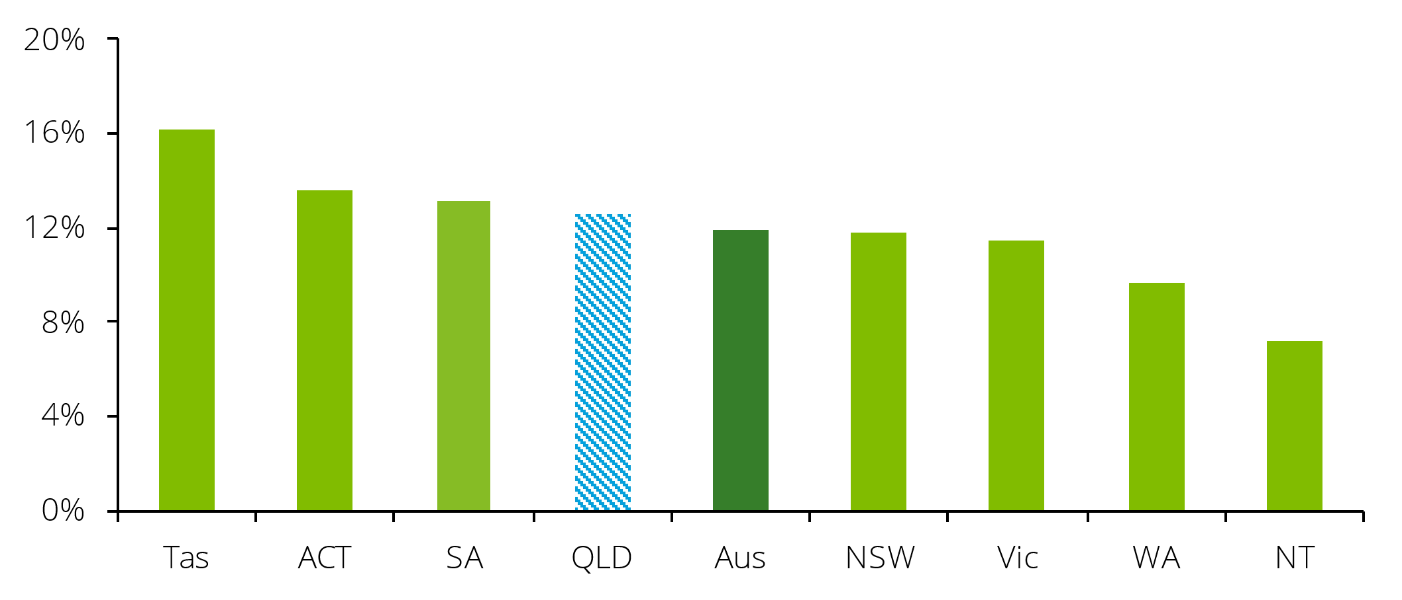

Source: SDAC 2022, Deloitte Access Economics.

Informal carers are playing an increasingly vital role in Queensland, with **the number of carers growing by a staggering 39% between 2015 and 2022**. This significantly outpaces the national average of 13% and means that Queensland is the fastest-growing state for informal carers over this period.

The rapid growth in informal carers is partly being driven by increased demand for care. The number of Queenslanders with a disability increased by 28% between 2015 and 2022, compared to the national average of 21%, while the number of Queenslanders aged over 60 increased by 27%, compared to the national average of 21% (see Chart 1.2). Other jurisdictions, such as the Australian Capital Territory and Western Australia, are also experiencing a significant rise in informal carer numbers due to an ageing population and a growing incidence of disability.

However, the ratio between growth in carers and growth in underlying demand is much higher in Queensland (1.41) than in any other jurisdiction (Australian average is 0.59), suggesting something other than underlying demand is driving growth in carers. One possible reason for this could be that more people in Queensland have identified as carers over this recent period. The ratio of carers per person with a disability and person aged over 60 is now similar in Queensland to other jurisdictions, suggesting the recent growth represents a ‘catching up’ in identification of carers.

Chart 1.2: Growth in the number of carers and demand for care, 2015-2022

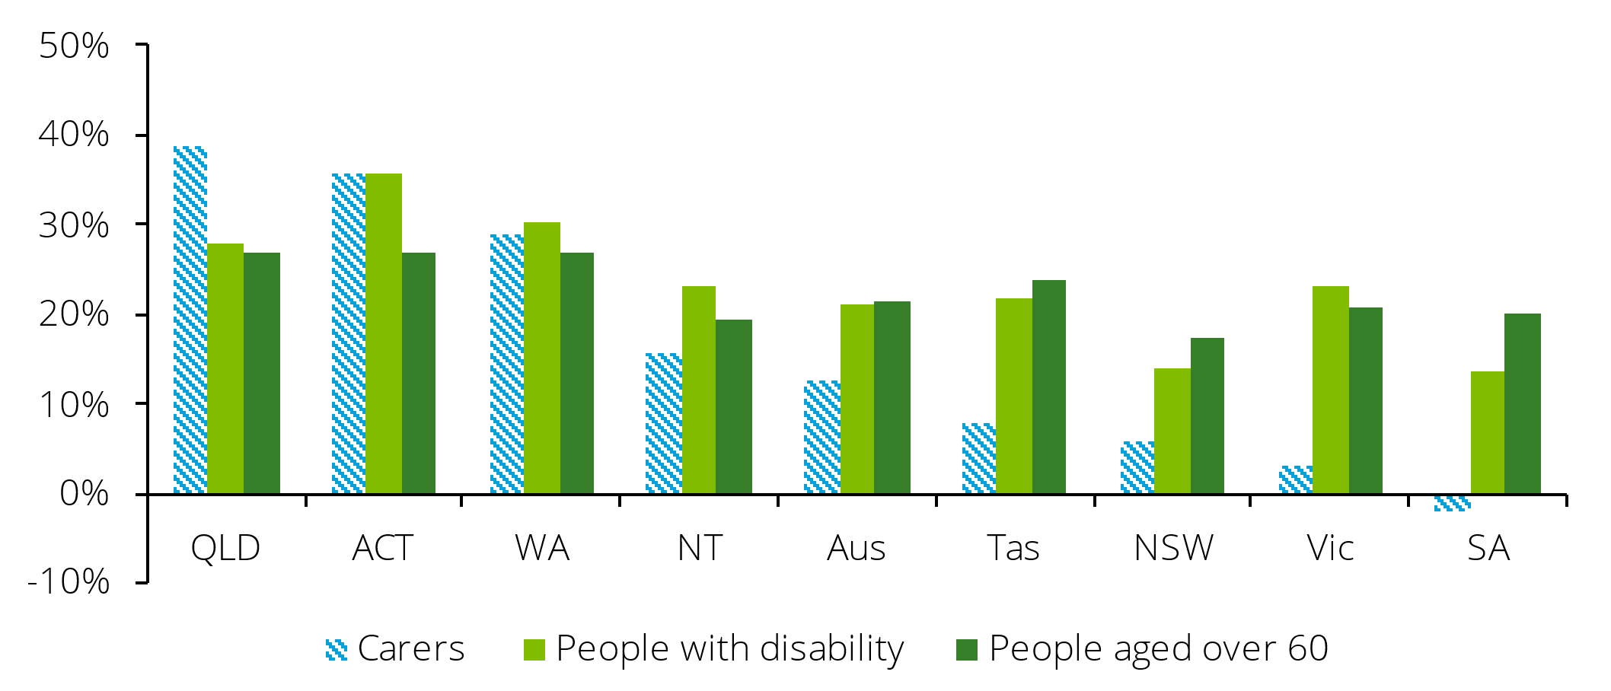

Source: SDAC 2015, SDAC 2022, Deloitte Access Economics.

Note: Contents of chart are described in the paragraph above in Section 1.2. A table of this chart also appears in Appendix D.

### Gender and age

**Most informal carers in Queensland are female (55%)**. However, when considering only primary carers, females make up over two-thirds of carers (68%) (see Chart 1.3). The primary carer role is typically more intensive and time-consuming, suggesting that most of the hours of informal care are being provided by women (see section 1.2.2 for more on intensity of care).

Chart 1.3: Number of informal carers by carer type and gender, 2022

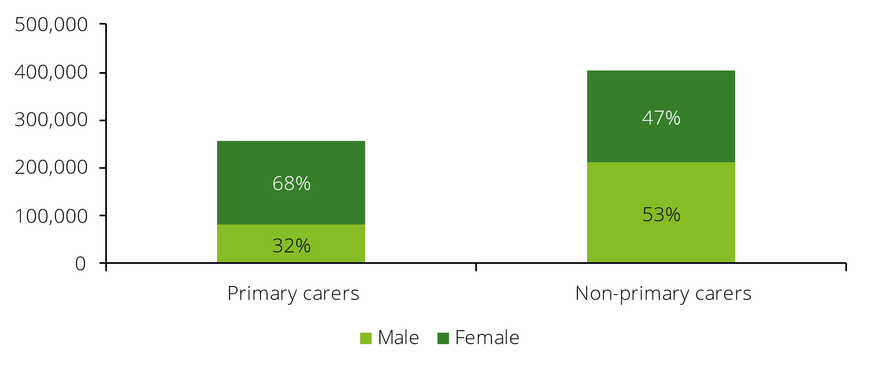

Source: SDAC 2022, Deloitte Access Economics.

**On average, informal carers in Queensland are approximately 49.5 years old.** Primary carers tend to be older than non-primary carers, with an average age of 53.3 years old compared to 47.0. This is being driven by a large cohort of younger non-primary carers, with nearly one-third (30%) of non-primary carers aged below 35 years old compared to just 13% of primary carers (see Chart 1.4).

This age profile may reflect role differences. Primary carers typically take on the most responsibility for daily care, which would likely fall to middle-aged or older family members, such as spouses or adult children. Non-primary carers, on the other hand, may provide occasional support and may be more likely to be younger relatives, such as adult grandchildren or siblings.

Chart 1.4: Age distribution of informal carers by carer type, 2022

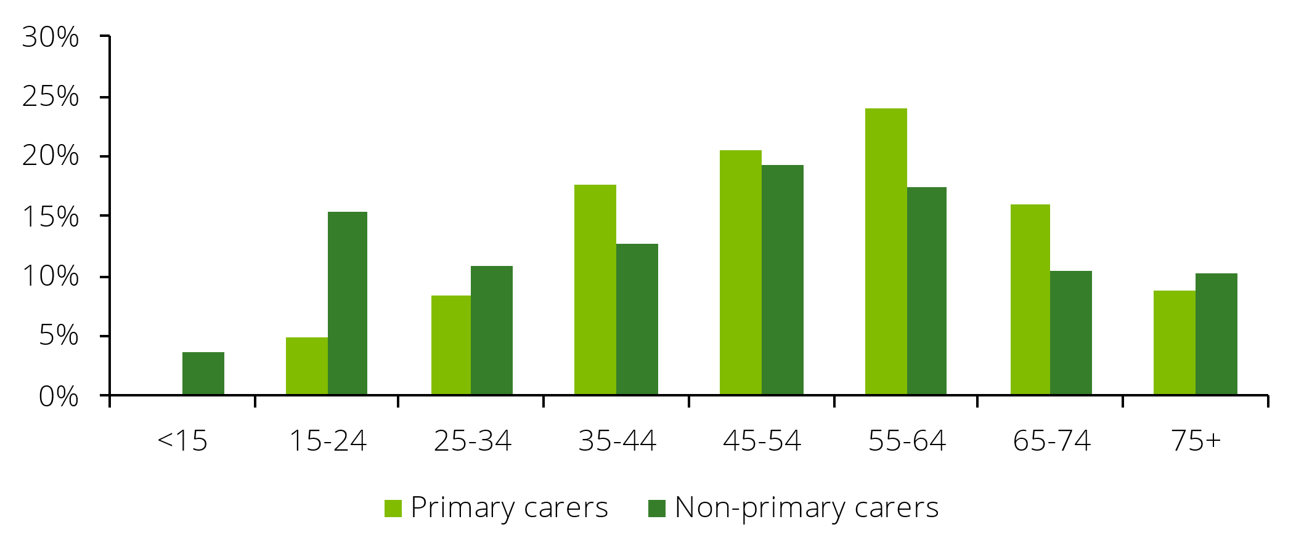

Source: SDAC 2022, Deloitte Access Economics.

Note: According to the SDAC definition, primary carers are aged above 15 years old.

Male and female informal carers are, on average, around the same age at 49.5 years old. However, despite the average being the same, the age distribution varies considerably by gender, revealing a difference in the role of male and female carers.

Male carers are more likely to be aged between 15 and 34 years old, or over 65 years old, while female carers are typically aged between 35 and 64, with 60% of female carers falling into this age bracket (see Chart 1.5). Female carers therefore play a more significant role during working age compared to male carers.

Although male carers are more likely to be aged between 15 and 34, the total number of female carers within this age range is higher. This illustrates that although men in this age group have a higher likelihood of taking on a caring role, the overall responsibility of caring still falls more heavily on women due to their greater representation in absolute terms.

Chart 1.5: Age distribution of informal carers by gender, 2022

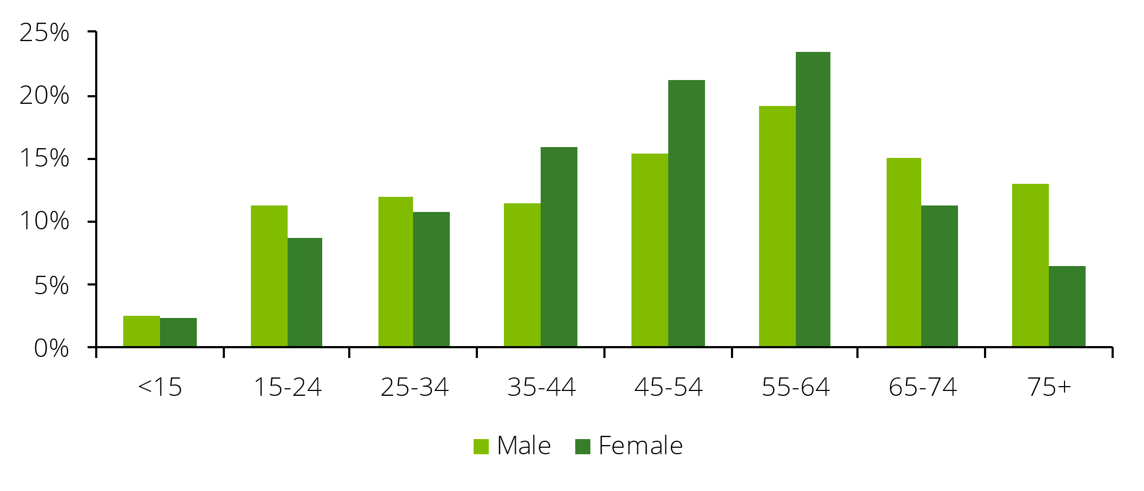

Source: SDAC 2022, Deloitte Access Economics.

**Since 2015, informal carers in Queensland have become marginally younger**, with the average age of informal carers decreasing from 50.2 to 49.5. This is despite the average age for the entire Queensland population increasing from 37.6 to 39.1 over the same period. This indicates that there is an increasing number of younger individuals assuming caregiving roles. Indeed, the share of informal carers aged between 15 and 24 years old increased from 7% to 11% between 2015 and 2022 (see Chart 1.6).

Chart 1.6: Age distribution of informal carers over time, 2009-2022

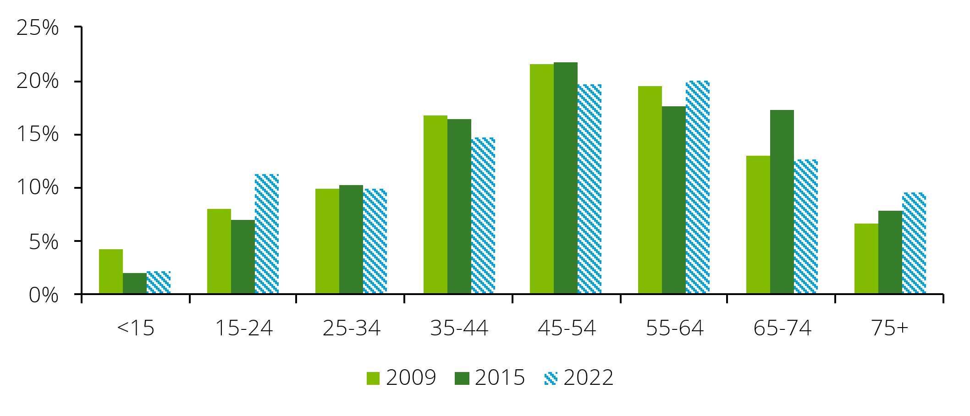

Source: SDAC 2009, SDAC 2015, SDAC 2022, Deloitte Access Economics.

Note: Contents of chart are described in the paragraph above in Section 1.2.1. A table of this chart also appear in Appendix D.

### Characteristics of care provided

**Half of informal carers in Queensland provide between 1-9 hours of care per week on average.** However, primary carers tend to provide significantly more care, with 21% providing over 60 hours of care per week and almost half (45%) providing more than 19 hours per week(see Chart 1.7). Only 15% of non-primary carers provide more than 19 hours of care per week.

Chart 1.7: Average hours of care provided per week by carer type, 2022

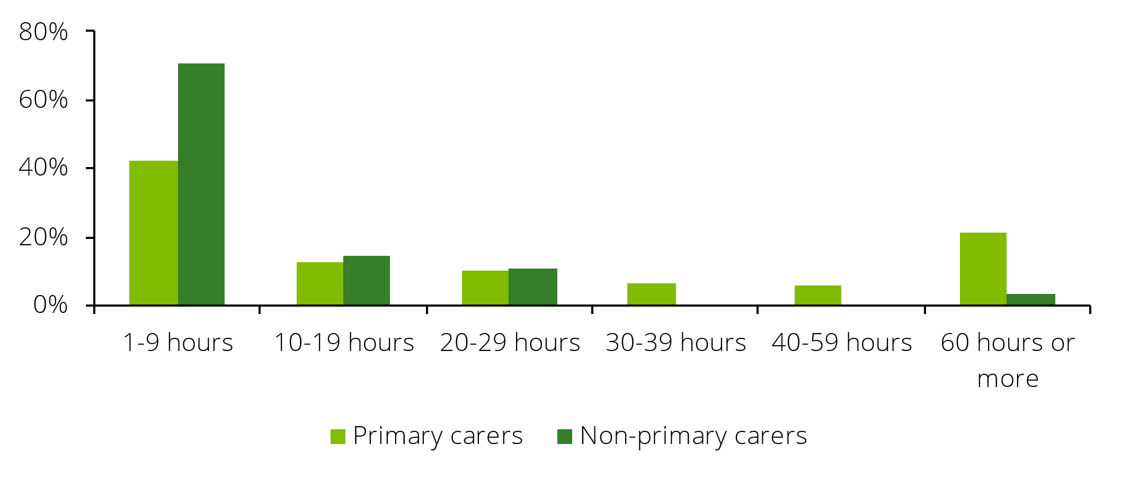

Source: SDAC 2022, Deloitte Access Economics.

**Female carers tend to provide more care than male carers**, with 41% of female carers providing more than 19 hours of care per week on average compared to 31% of male carers (see Chart 1.8). Over half (59%) of male carers provide between 1-9 hours per week of care on average.

Chart 1.8: Average hours of care provided per week by gender, 2022

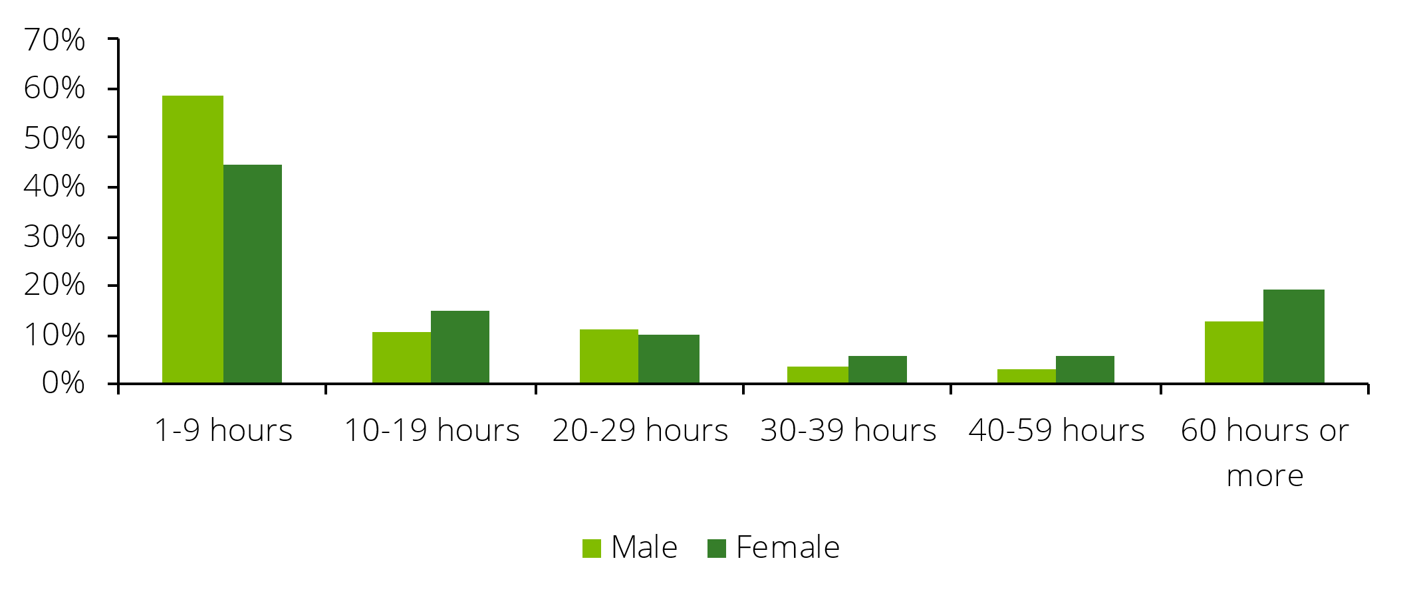

Source: SDAC 2022, Deloitte Access Economics.

**Significantly more care is required for individuals who are ‘profoundly limited in their ability to engage in core activities’.** Over half (58%) of carers who care for an individual who is ‘profoundly limited in their ability to engage in core activities’ spend 30 or more hours per week doing so (see Chart 1.9).[7] However, only 22% of carers who care for individuals who are ‘severely limited in their ability to engage in core activities’ spend this amount of time on care.

Chart 1.9: Average hours of care provided per week by disability status, 2022

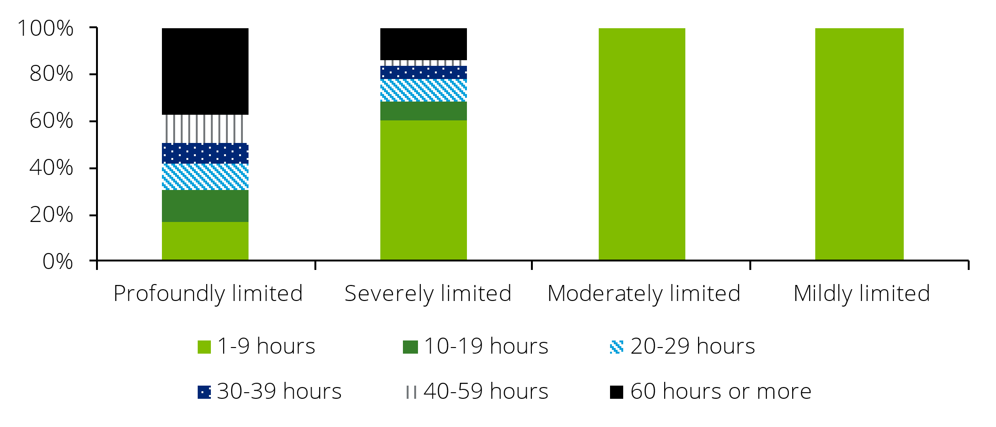

Source: SDAC 2022, Deloitte Access Economics.

Note: Due to data suppression issues care recipients who are not limited in core activities are not presented in this chart. Contents of chart are described in the paragraph above in Section 1.2.2. A table of this chart also appear in Appendix D.

**The majority of informal carers (86%) care for one individual**, while 14% care for two or more individuals (see Chart 1.10). This means that most informal carers focus their time and resources on a single care recipient, which may allow them to provide more dedicated and consistent support.

Chart 1.10: Number of care recipients, 2022

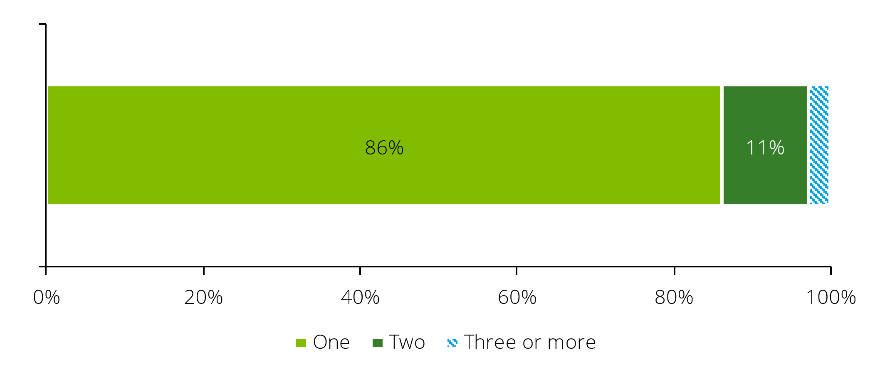

Source: SDAC 2022, Deloitte Access Economics.

### Employment and income

Providing care can often involve significant time and commitment. As a result, a carer may adjust their working hours or step away from the workforce entirely so that they can continue providing care. Consequently, informal carers tend to participate less in the workforce compared to the rest of the population. **Almost half (46%) of all primary carers in Queensland were not participating in the labour market in 2022.** This compares to 33% of non-primary carers and 30% of non-carers (see Chart 1.11). Given that the majority of primary carers are older women, adverse employment outcomes for primary carers contributes to gender-based economic inequalities, particularly in later years of life, as foregone earnings and superannuation contributions lead to large differences in wealth at retirement age.

Full time employment levels are also lower for informal carers compared to the rest of the population. Approximately 26% of primary carers and 42% of non-primary carers are employed full-time compared to 46% of non-carers. A large proportion of informal carers work part time, likely reflecting the significant time commitment that caring requires. Approximately 26% of primary carers and 23% of non-primary carers are employed part-time compared to 22% of non-carers.

Chart 1.11: Employment status of informal carers by carer type, 2022[8]

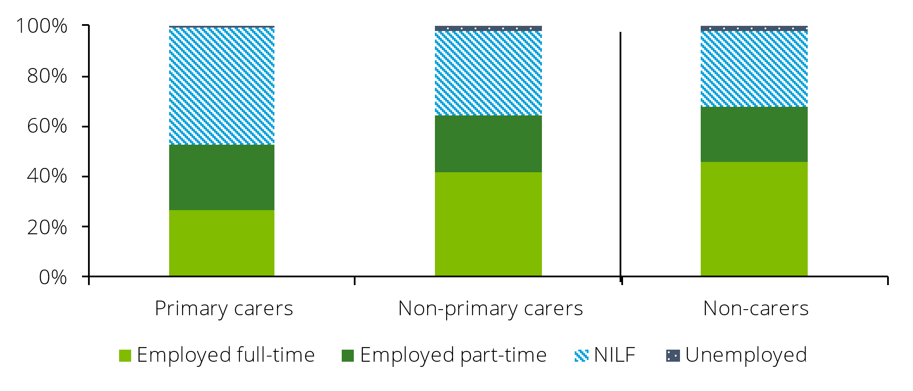

Source: SDAC 2022, Deloitte Access Economics.

Note: This sample is restricted to the working age population. Contents of chart are described in the paragraph above in Section 1.2.3. A table of this chart also appear in Appendix D.

**Participation of carers in the labour force has improved over time, particularly for primary carers.[9]** Since 2015, the participation rate of primary carers in Queensland has increased by11 percentage points to 54%. Most of this gain has been in full-time employment, which has increased by 10 percentage points over the period to 26% of primary carers. Non-primary carers have also seen gains, with participation increasing by 4 percentage points over the period (see Chart 1.12). In comparison, the participation rate of non-carers has remained steady at 70%.

Improved labour market outcomes over this period could reflect several factors, including the rollout of the NDIS, the proliferation of work-from-home, a strong labour market and increasing costs of living.

Chart 1.12: Participation rate of informal carers over time, 2015-2022

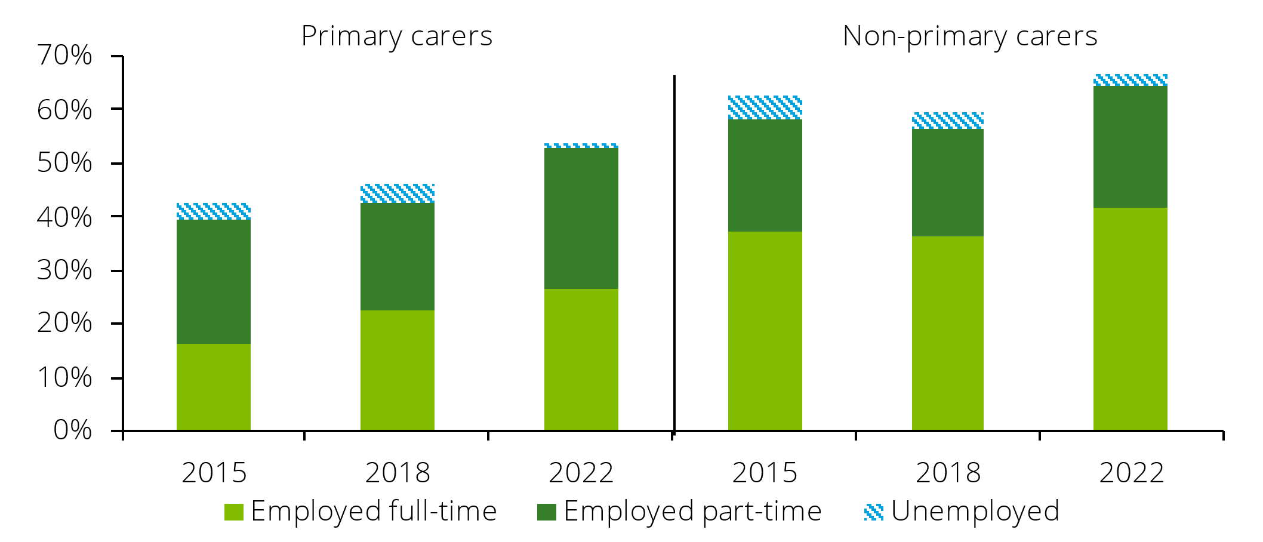

Source: SDAC 2015, SDAC 2018, SDAC 2022, Deloitte Access Economics.

Note: This sample is restricted to the working age population. Contents of chart are described in the paragraph above in Section 1.2.3. A table of this chart also appear in Appendix D.

**Informal carers generally have lower incomes compared to the rest of the population.** Approximately 48% of primary carers and 41% of non-primary carers earn an average weekly income in the bottom two income quintiles compared to 39% of non-carers (see Chart 1.13).Carers are most likely to fall within the second income quintile, while non-carers are more evenly disbursed.This likely reflects the higher proportion of carers being part-time workers, but could also reflect other factorssuch as carers being more likely to work in lower paying occupations.

Chart 1.13: Income distribution by carer type, 2022

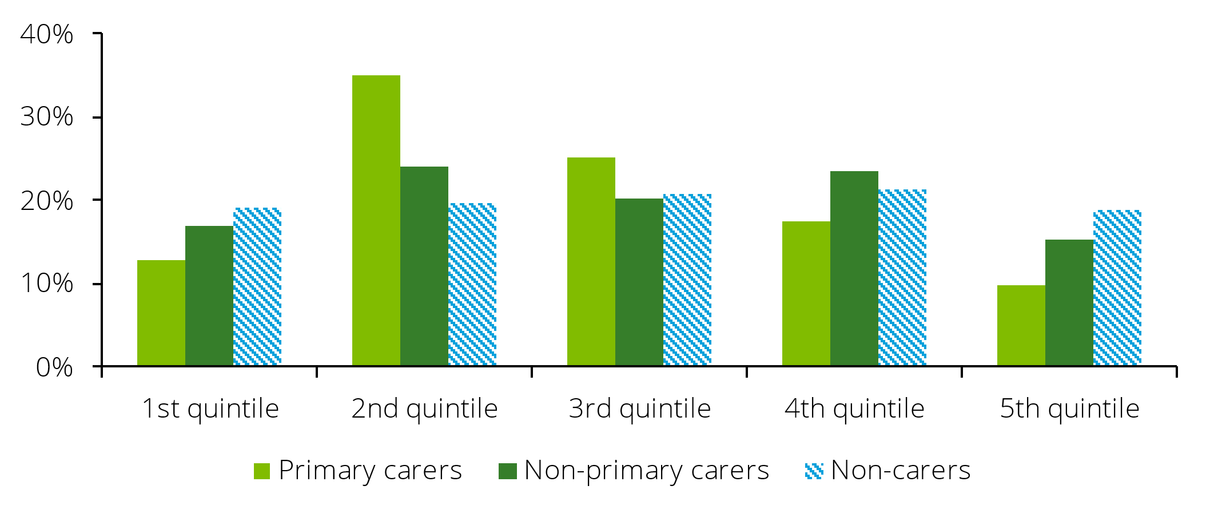

Source: SDAC 2022, Deloitte Access Economics.

Note: This sample is restricted to the working age population. The SDAC does not publish ranges for income quintiles, however the ABS Australian National Accounts series provides the following average gross disposable incomes for each income quintile for 2021-22: 1st quintile: $54,134, 2nd quintile: $86,689, 3rd quintile: $117,495, 4th quintile: $154,434, 5th quintile: $288, 311. [10] Contents of chart are described in the paragraph above in Section 1.2.3. A table of this chart also appear in Appendix D.

**Carers are more reliant on non-labour sources of income such as government pensions and allowances, including the Carer Allowance and Carer Payment.** Approximately 37% of primary carers and 22% of non-primary carers rely on supports such as these as their main source of income compared to 14% of non-carers (see Chart 1.14). This is likely driven by carers participating less in the labour market, resulting in them earning lower employment incomes.

Chart 1.14: Main source of income by carer type, 2022

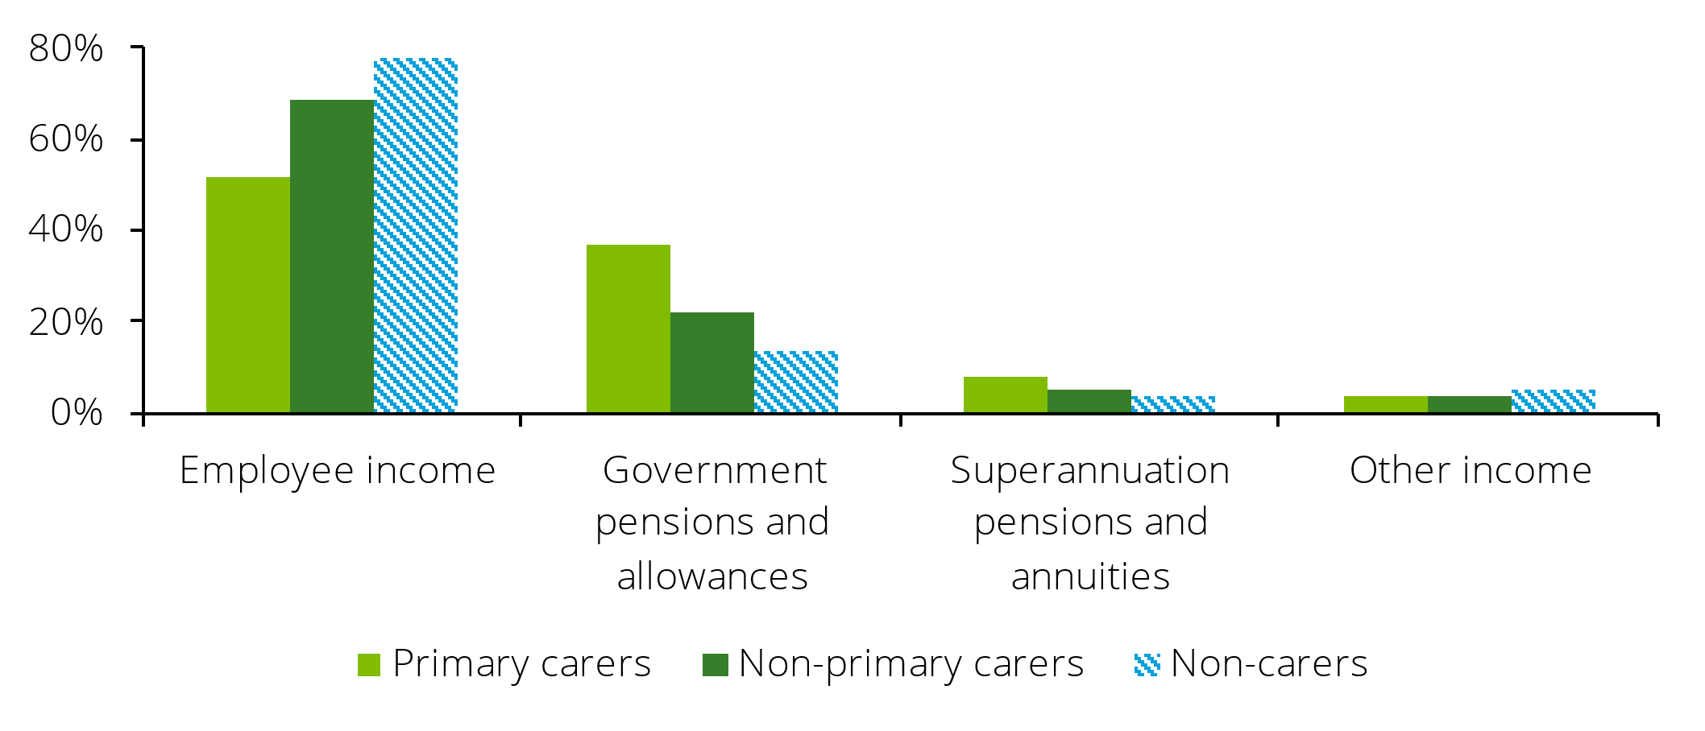

Source: SDAC 2022, Deloitte Access Economics.

Note: This sample is restricted to the working age population. Contents of chart are described in the paragraph above in Section 1.2.3. A table of this chart also appear in Appendix D.

### Diversity

**Informal carers share similar diversity characteristics with the broader non-carer population**. Approximately 25% of primary carers and 21% of non-primary carers are migrants compared to 24% of non-carers (see Chart 1.15). However, this figure is likely under-estimated due to under-reporting and difficulties in identifying caring roles within the migrant community, especially when there can be multiple carers providing different supports.[11] Approximately 4% of carers identify as non-heterosexual compared to 3% of non-carers.[12] However, a larger share of informal carers in Queensland identify as Aboriginal or Torres Strait Islander (7%) compared to the overall population of Queensland (5%) according to the 2024 National Carer Survey (NCS). This number may understate the true number of First Nations carers, as some First Nations people may not identify with the term ‘carer’.11 Instead, care is seen as an important cultural responsibility. The larger share of First Nations carers may be partially driven by the higher proportion of First Nations people with a disability. According to the SDAC, approximately 25.3% of First Nations people have a disability compared to 21.4% of the entire population.

Chart 1.15: Migrant status by carer type, 2022

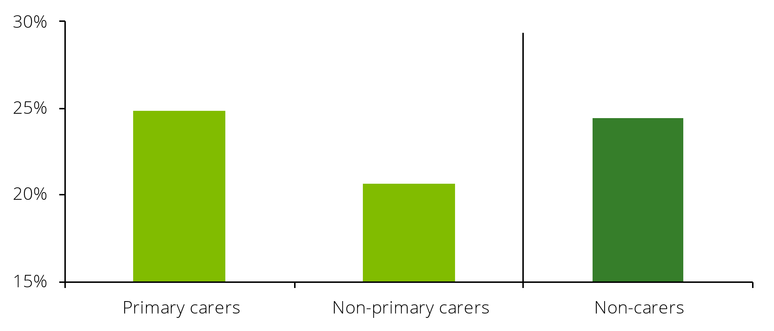

Source: SDAC 2022, Deloitte Access Economics.

### Location

**Carers tend to live in major cities or regional areas.** Carers make up approximately 5% of the population of major cities and regional areas, but almost none of remote populations (see Chart 1.16). This is despite remote areas having a similar share of the population with a disability compared to major cities. This may be caused by a difference in cultural norms and perceptions of caregiving between urban and remote areas. Individuals providing care in some communities may not self-identify as ‘carers’, rather viewing their support as a customary family or community responsibility. While there is limited research on this hypothesis in Australia, a study of individuals caring for family members with dementia in Sweden found that rural caregivers often adopted a more accepting approach, viewing caregiving as a natural part of life.[13] In contrast, urban caregivers frequently perceived caregiving as an obligation that restricted their personal space.

Chart 1.16: Informal carer share of population by remoteness level, 2022

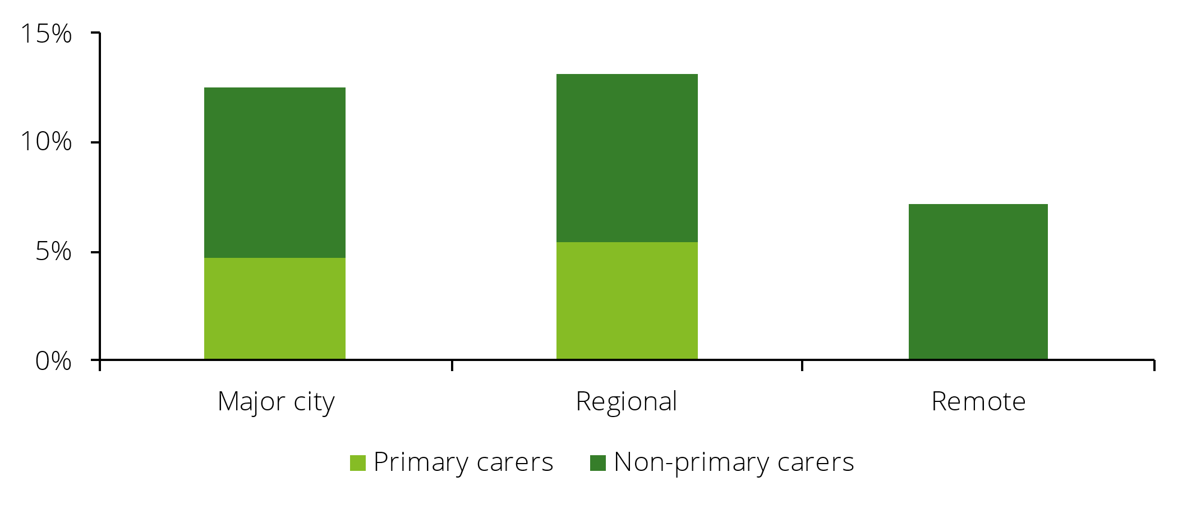

Source: SDAC 2022, Deloitte Access Economics.

### Demographics of care recipients

**The main recipients of care tend to be older women**, with approximately 26% of all main care recipients being women aged 65 and over (see Chart 1.17). However, younger main care recipients are more likely to be male with 10% of main care recipients being males under 15 years old.

Chart 1.17: Age and gender of main care recipient, 2022

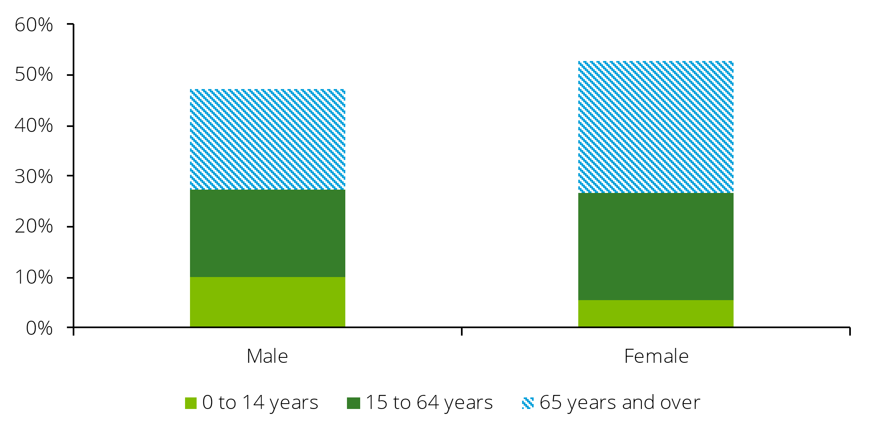

Source: SDAC 2022, Deloitte Access Economics.

Note: Contents of chart are described in the paragraph above in Section 1.2.6. A table of this chart also appear in Appendix D.

**The disability status of main care recipients tends to be quite severe**, with approximately 96% of main care recipients being ‘profoundly restricted’ or ‘severely restricted’ in their ability to engage in core activities (see Chart 1.18).

Chart 1.18: Disability status of main care recipients, 2022

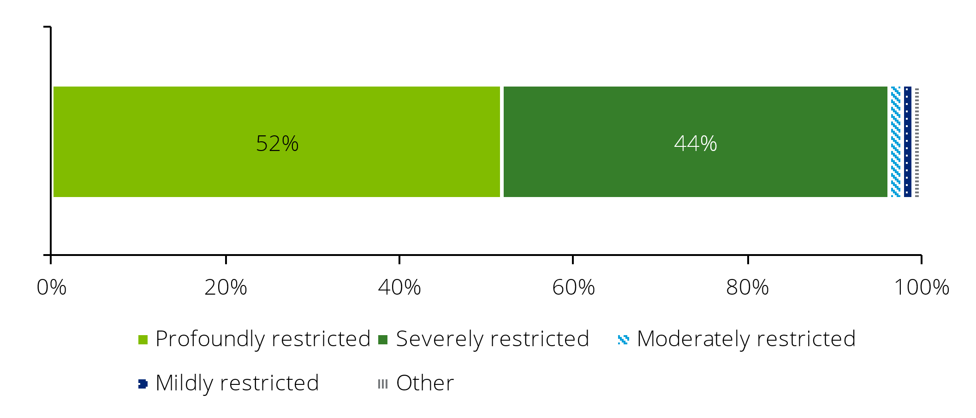

Source: SDAC 2022, Deloitte Access Economics.

Note: Contents of chart are described in the paragraph above in Section 1.2.6. A table of this chart also appear in Appendix D.

**Main care recipients are most likely to be related to their primary carer**. Approximately 38% of primary carers are the partner of their main care recipient, while 30% are a parent and 24% are a child (see Chart 1.19).

Chart 1.19: Relationship of primary carers to their main recipient of care, 2022

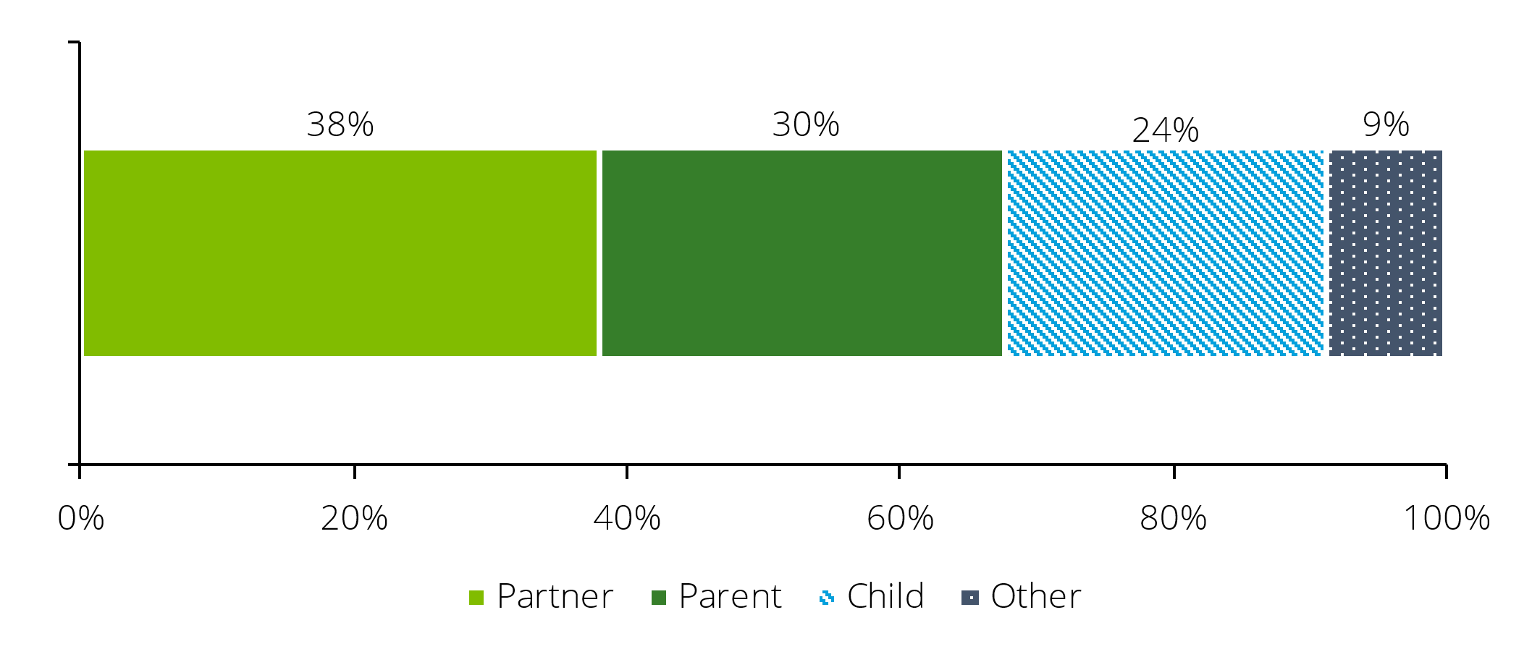

Source: SDAC 2022, Deloitte Access Economics.

Note: Contents of chart are described in the paragraph above in Section 1.2.6. A table of this chart also appear in Appendix D.

# Economic value of informal care in Queensland

**Key findings:**

* It is estimated that in 2022 approximately 657,000 informal carers in Queensland spent a total of **484 million hours providing care.**
* The economic value of this care is estimated to be $22.5 billion - that is what it would cost to *replace* Queensland’s informal carers with formal care providers. This represents approximately half of the economic output of the entire healthcare and social assistance sector in Queensland as of June 2024.
* Primary carers account for most of this value, with a replacement cost value of $16.5 billion (73%), compared to $6.0 billion for non-primary carers.

Informal carers are not paid for providing care, but their value is not ‘free’ in an economic sense. Time spent caring involves forfeiting time that could have been spent in paid work or leisure.

There are a number of methods that can be used to place a dollar value on informal care. One method which is readily communicated and understood is the replacement cost method. This method measures the cost of ‘buying’ an equivalent amount of care from the formal sector if informal care was not supplied. Section 2.1 below presents the replacement cost of informal care in Queensland.[14]

## Replacement cost valuation

**In total, it is estimated that approximately 657,000 informal carers spent 484 million hours providing care in Queensland in 2022. The economic value of this care to the Queensland economy is estimated to be approximately $22.5 billion.** This represents the cost to replace the care provided by informal carers with paid formal sector carers. This is equivalent to approximately half of the economic output of the entire healthcare and social assistance sector in Queensland as of June 2024.[15] The care provided by primary carers contributes most of this value at $16.5 billion compared with $6.0 billion for non-primary carers.

A small portion of the replacement cost ($1.7b) relates to the costs of administering the formal care system. However, the vast majority ($20.8b) could be viewed as income foregone by informal carers, as this is the market value of the work that they provide. These forgone earnings, including superannuation, greatly diminish economic security for carers and their families.

Applying this replacement cost methodology to the total number of carers in Australia from the 2022 SDAC (3.0 million) who collectively provide approximately 2.4 billion hours of care results in a replacement cost of $110.8 billion for the whole of Australia.[16] From this, Queensland’s replacement cost represents 20.3% of the replacement cost for the whole of Australia which is in line with Queensland’s share of Australia’s total population (20.5%).[17]

### Methodology and data

This section outlines the methodology used to calculate the replacement cost valuation of informal carers in Queensland. The approach is aligned with the methodology used by previous Deloitte Access Economics reports on the value of informal care in Australia.[18] For a detailed explanation of the methodology, see Appendix A.

The approach comprised three steps:

1. **Estimating annual hours of informal care provided in Queensland:** Data from SDAC was used to estimate weekly hours of care provided by ‘primary’ and ‘secondary’ carers. For ‘other’ carers, an average of five hours per week was assumed. It was estimated that informal carers in Queensland provided approximately 484 million hours of care in 2022.
2. **Determining the average hourly wage for formal care:** The replacement value was estimated by combining the total hours of informal care by the average wage rate for formal carers.[19]
3. **Calculating additional loading costs associated with employment:** To fully capture the total costs associated with the employment of carers, on-costs are also incorporated. These costs reflect the costs incurred by employers in addition to the wage, such as payroll tax and leave loadings, and also additional costs to the system that would accrue if informal care was organised in a formal labour market, such as costs of capital overheads and supervision. Table 2.1 illustrates how hourly wage rates are combined with on-costs to estimate the cost of replacing informal care.

Table 2.1: Replacement valuation of informal care, unit cost component

|  |  |  |
| --- | --- | --- |
| **Component** | **Loading** | **Hourly rate** |
| Hourly rate including overheads – May 2023 |  | $38.50 |
| Loading for wage growth – May 2023 to December 2024 | 7.36% | $2.83 |
| Loading for on-costs (payroll tax, workers compensation, fringe benefits) | 4.24% | $1.63 |
| Loading for capital | 6.24% | $2.40 |
| Loading for administration & supervision | 2.96% | $1.14 |
| **Total hourly rate including overheads – December 2024** |  | **$46.51** |

Source: Deloitte Access Economics using data from ABS Earnings and Hours survey (2023).

### Discussion

One possible limitation of this approach is that the replacement cost valuation does not consider any differences in efficiency of providing care between informal and formal carers. For example, many informal carers will only provide care to one recipient (typically a friend or family member), while formal sector carers will often provide care to multiple people at the same time in the community and residential settings.[20] This means that care in the formal sector may be more efficient than care provided by informal carers and, as such, the estimated replacement cost may be lower than estimated, depending on the level of such conjoint activity or other scale efficiencies.

However, there are also losses of efficiency associated with care in the formal sector that offset efficiencies achieved through lower carer ratios. In order to match the number of hours and intensity of care provided by informal carers, a formal carer may need to spend more hours overall. This may arise due to the need to attend paid training or to travel between locations of care. These upside and downside risks work in opposite directions and to some extent may offset each other. Nonetheless, they are worth considering when interpreting the results of this analysis.

Another limitation of this methodology is that the replacement cost assumes each informal carer is replaced by a single formal sector carer. However, this assumption may not always hold. The care provided by informal carers is often multifaceted; an individual carer may provide care to multiple individuals with different needs, and the tasks performed by a single carer may require two or more formal sector carers if they were replaced. As such, the replacement cost may underestimate the true value of care provided by the informal carers.

### Sensitivity analysis

Different wage estimates for the formal care sector can be used to derive alternative replacement cost valuations. For the baseline result, cash earnings for full-time Personal Carers and Assistants from the 2023 Employee Earnings and Hours survey were used. However, a lower bound replacement cost can be derived using the Social, Community, Home Care and Disability Services Industry (SCHADS) award, which is the minimum pay rate for an employee in this industry.[21] Adjustments were made to this base wage to account for on-costs, capital, and administrative costs following the same methodology presented in section 2.1.1. Adjustments were also made for superannuation loading which is not included in the SCHADS award base wage (see Table 2.2).

Table 2.2: Replacement valuation of informal care, SCHADS award wage

|  |  |  |  |
| --- | --- | --- | --- |
| **Component** |  | **Loading** | **Hourly rate** |
| Hourly rate including overheads – March 2025 |  |  | $26.80 |
| Loading for on-costs (payroll tax, workers compensation, fringe benefits) |  | 4.24% | $1.14 |
| Loading for capital |  | 6.24% | $1.67 |
| Loading for administration & supervision |  | 2.96% | $0.79 |
| Loading for superannuation |  | 11.50% | $3.08 |
| **Total hourly rate including overheads – March 2025** |  |  | **$33.48** |

Source: Deloitte Access Economics using data from SCHADS award.

**Applying the above hourly rate of formal care to the total hours of informal care provided in Queensland yields a total replacement cost of approximately $16.2 billion.**

Alternatively, the NDIS price cap on disability support workers can be used to estimate what could be considered an upper bound for the replacement cost of informal carers. This price represents the maximum rate that providers can charge for specific services rendered to participants. This cap is currently $67.56 per hour and requires no extra adjustment as price limits are fully loaded.[22]

**Applying this hourly rate to the total hours of informal care provided in Queensland yields a total replacement cost of approximately $32.7 billion.**

However, while this estimate provides an approximate upper bound, the NDIS price cap does not necessarily reflect the labour costs and likely includes a margin for providers. The size of this margin is uncertain, but nevertheless provides support for the NDIS price cap method representing an upper bound.

The previous replacement cost estimates assume that carers who are neither primary nor secondary carers spend an average of five hours per week providing care. To provide an upper and lower bound around this assumption, two additional scenarios were considered. Scenario B assumes that these carers spend 2.5 hours per week providing care, while Scenario C assumes that carers provide 7.5 hours of care per week (see Table 2.3).

**Under Scenario B, the replacement cost of informal carers in Queensland is approximately $20.5 billion, while under Scenario C the replacement cost is approximately $24.5 billion.**

Table 2.3: Sensitivity analysis for the average hours of non-primary and non-secondary care on the total replacement value

|  |  |  |  |  |
| --- | --- | --- | --- | --- |
| **Scenario** | **Weekly hours of care for non-primary and non-secondary carers** | **Annual hours of care (000s)** | **Replacement cost, non-primary & non-secondary carers ($, millions)** | **Replacement cost, total ($, millions)** |
| A (central) | 5 | 83,980 | 3,906 | 22,500 |
| B (lower) | 2.5 | 41,990 | 1,953 | 20,547 |
| C (upper) | 7.5 | 125,970 | 5,859 | 24,452 |

Source: Deloitte Access Economics estimates.

# Services for Carers in Queensland

**Key findings:**

* A desktop review of services available to support informal carers in Queensland has identified **67 unique services across eight service categories**.
* **The largest unmet service needs identified for carers in Queensland are in respite care.**
* The cost of providing an additional unit of support for carers with unmet needs within each service category is estimated to be approximately **$380 million**.

Informal carers provide crucial support for individuals and play an important role in the Queensland economy. Despite this, many carers experience poor wellbeing, are less likely to participate in the labour market and can face financial pressures.

Both Commonwealth and State governments play an important role in providing support for these individuals to ensure the value of care is acknowledged and their wellbeing is maintained. This support encompasses services such as education, training, financial support, and respite options, enabling carers to effectively manage their responsibilities while safeguarding their own wellbeing.

This section outlines the current services available to carers in Queensland and uses the 2024 National Carer Survey to identify where gaps in services for informal carers exist.

## Current services for carers in Queensland

Deloitte Access Economics conducted a desktop review of services available to support informal carers in Queensland. This research identified **67 unique services across eight different service categories** (see Table 3.1). Each service is classified under a primary service category, with a secondary category assigned when applicable to reflect the multiple types of support provided by a specific service. As a result, the total number of services presented below is greater than the 67 individual services identified.

The services identified encompass general support for all informal carers, as well as specialised assistance for those caring for individuals with specific conditions, such as Dementia or Alzheimer’s disease. Of the services identified, 24 are reported to be accessible across Queensland, 14 are accessible in Brisbane and regional towns respectively, and 33 are accessible nationally or in multiple states including Queensland.[23] Approximately 39% of the 67 services identified are reported to be only available online, while 24% are offered exclusively in-person. The remaining 37% are available in both online and in-person settings.

Table 3.1: Current services available to informal carers in Queensland

|  |  |
| --- | --- |
| **Service category** | **Number of services available** |
| Support for specific conditions | 28 |
| Education, information and training | 25 |
| Mental health / emotional support | 21 |
| Financial support | 13 |
| Social connection | 13 |
| Young carer service | 8 |
| Respite | 8 |
| Employment and workplace support | 1 |

Source: Deloitte Access Economics.

**A wide range of services are available to support carers who provide care to people with specific conditions.** These conditions include Dementia, Alzheimer’s disease and people who are reaching the end of their life or are in palliative care. These services often involve providing skills training to carers to equip them to effectively manage the unique challenges associated with each condition.

**One of the most accessible types of support for informal carers in Queensland is education, information and training**. This support is delivered through multiple forms, including information sessions, workshops and telephone support lines. Most major carer service providers in Queensland offer this type of support, with many also providing online materials on their website for carers to access at their own convenience. These services enable carers to access knowledge, skills and guidance to better navigate their caregiving responsibilities. Education and training can also help carers understand medical conditions, learn practical caregiving techniques, and develop coping strategies for managing burnout and stress.

**There are also numerous services available for mental health and emotional support.** These are commonly offered in the forms of telephone helplines, peer support groups, counselling and one-on-one coaching. These services are designed to help carers manage stress, reduce feelings of isolation, and maintain their overall wellbeing while balancing their caregiving responsibilities. All of the services identified within this category can be delivered online, which enables carers from both metro and regional areas to access the services.

**The search revealed a limited number of employment and workplace support services.** Just one service was identified – the Your Caring Way program, which assists carers in pursuing their own goals such as education or employment. Given that informal carers have more difficulty participating in the labour force (see section 1.2.2), this presents a gap in the carer support system. Additionally, as a large proportion of carers spend most of their week providing care, many may have been out of the labour force for a number of years. As such, they may require pre-employment support services such as resume and interview preparation to be able to confidently re-engage in the workforce.

**There are also a limited number of respite services available for carers in Queensland.** Out-of-pocketcosts are also often associated with accessing the services and availability is scarce, with many respite services only offered once or twice a year. Additionally, carers in regional and remote areas face even greater challenges due to the scarcity of respite options in these locations.

**There also very few dedicated services available for First Nations and culturally diverse carers.** No services were identified as being specifically designed for First Nations carers, and only two exist for culturally diverse carers. Culturally appropriate and targeted services are essential for these groups, as First Nations people have higher rates of disability, and both First Nations and culturally diverse carers may not always self-identify as carers, making them less likely to seek support.11

## Carer needs and identification of service gaps

Despite the services currently being provided for carers, they are still reporting high rates of stress and lower rates of wellbeing and life satisfaction. According to the 2024 NCS, 62% of carers reported low or very low personal wellbeing. This suggests there are currently gaps in services for carers, jeopardising their wellbeing and also their ability to perform their caring role sustainably.

This section uses data from the 2024 NCS to identify where gaps exist for informal carers in Queensland. While the survey uses fewer service categories than the previous section, each service identified previously has been reclassified according to the categories in the NCS.

The NCS is the most comprehensive source available to identify service gaps for carers in Queensland. The survey includes a sample of approximately 600 carers in Queensland. While it is not specified in the survey, most respondents are likely to be primary carers as approximately 70% of respondents spend more than 40 hours per week on average providing care.

The largest unmet need identified in the NCS for carers in Queensland was emergency respite, with almost half (46%) of respondents identifying that their needs were unmet in this area (see Table 3.2 ).[24] This is closely followed by planned respite, with 44% of respondents citing an unmet need. These findings align with the service identification results, which highlights the limited availability of respite services for carers, particularly in regional Queensland. Additionally, the significant need for respite care reflects the large number of carers who dedicate substantial hours to caregiving each week presented in section 2.3. Over a fifth of primary carers (21%) provide more than 60 hours of care per week on average.

Table 3.2: Unmet needs for informal carers

|  |  |  |
| --- | --- | --- |
| **Service category** | **Share of respondents with unmet needs** | **Number of services available** |
| Emergency respite | 46% | 2 |
| Planned respite | 44% | 3 |
| Carer counselling | 43% | 6 |
| Carer coaching | 43% | 4 |
| Carer skills training | 43% | 16 |
| Carer peer support online | 42% | 8 |
| Carer support groups | 40% | 6 |

Source: 2024 National Carer Survey, Deloitte Access Economics.

Unmet needs are particularly pronounced among certain groups of carers, such as those in paid work. On average across all service categories, 47% of carers in paid work identify unmet needs compared to an average of 41% of all carers (see Table 3.3). The most significant unmet needs for this group are in emergency respite and planned respite, with 53% and 51% of carers respectively identifying unmet needs. Diverse carers, such as those from First Nations or culturally diverse backgrounds, are also more likely to identify unmet service needs. An average of 47% of carers from both cohorts identified unmet needs across the various service categories. Again, emergency respite was the service category with the most unmet needs, with 54% of culturally diverse carers and 53% of First Nations carers reporting unmet needs.

Table 3.3: Unmet needs for informal carers by demographic characteristics

|  |  |  |  |  |  |  |  |
| --- | --- | --- | --- | --- | --- | --- | --- |
| **Service category** | **Female** | **Male** | **Aged 15-64** | **Aged 65+** | **First Nations\*** | **CALD\*** | **In paid work** |
| Emergency respite | 46% | 47% | 52% | 29% | 59% | 54% | 53% |
| Planned respite | 44% | 50% | 50% | 29% | 59% | 50% | 51% |
| Carer counselling | 43% | 42% | 47% | 33% | 41% | 46% | 49% |
| Carer coaching | 43% | 42% | 47% | 33% | 41% | 46% | 49% |
| Carer skills training | 43% | 42% | 47% | 30% | 59% | 48% | 49% |
| Carer peer support online | 42% | 40% | 47% | 29% | 41% | 52% | 49% |
| Carer support groups | 42% | 30% | 45% | 27% | 36% | 48% | 46% |

Source: 2024 National Carer Survey, Deloitte Access Economics.

*Fewer than 50 survey respondents. CALD stands for Culturally and Linguistically Diverse.

## Cost estimate to fill the carer support service gap

This section utilises the analysis of gaps in the carer support system explored in the previous section, alongside data from the 2024 Impact Evaluation of the Integrated Carer Support Service (Carer Gateway) to provide an illustration of what it might cost to narrow the service gaps in Queensland.[25]

## Methodology

To estimate the number of carers who have unmet needs in each service category across Queensland, the share of carers with unmet needs from the NCS was applied to the total population of carers in Queensland from the 2022 SDAC. Within the NCS each respondent was able to identify unmet needs for each service category meaning that an individual carer could express an unmet need in multiple service categories. This data does not provide any information on the quantum of the gap, or what would be required to close it. NCS data is leveraged alongside data from the 2024 Impact Evaluation of the Integrated Carer Support Service to open a dialogue about the gaps that may exist, and what it *could* cost to provide an additional unit of support where gaps exist.

Unit costs of providing carer services were derived from data included in UNSW Social Policy Research Centre’s 2024 Impact Evaluation of the Integrated Carer Support Service. This evaluation estimated the total cost of Carer Gateway in 2022 was approximately $130 million, providing almost 685,000 services to users. The evaluation identifies different types of services and categorises services as ‘high-cost’ or ‘low-cost’.[26]

From these inputs, the unit cost of high-cost services is estimated at $228.67 while the unit cost of low-cost services is estimated at $175.90. For a more detailed outline of the methodology see Appendix A.

Table 3.4: Unit costs of carer services

|  |  |
| --- | --- |
| Total cost of Carer Gateway | $130 million |
| Total number of services provided by Carer Gateway | 684,720 |
| Number of high-cost services | 181,116 |
| Number of low-cost services | 504,604 |
| **Unit cost of high-cost services** | **$228.67** |
| **Unit cost of low-cost services** | **$175.90** |

Source: 2024 Impact Evaluation of the Integrated Carer Support Service, Deloitte Access Economics.

The unit costs presented in Table 3.4 have been combined with the estimated number of carers with unmet needs within each service to provide an illustrative cost estimate of providing **one additional unit of support** for all carers identifying an unmet need (Table 3.5). This analysis does not specify what one unit of service means for each service type and is dependent on how service units have been defined in UNSW’s 2024 Impact Evaluation of the Integrated Carer Support Service. Illustratively, one unit of respite care could mean providing one full day of respite care (8 hours) or one overnight respite care.

Table 3.5: Cost to provide one additional unit of support for carers indicating an unmet need

|  |  |  |  |  |
| --- | --- | --- | --- | --- |
| **Service type** | **Service cost** | **Share of respondents reporting unmet needs (from NCS)** | **Number of carers in QLD with unmet needs** | **Cost to provide one unit of service for people with unmet need** |
| Emergency respite | High | 46% | 302,000 | 69,047,000 |
| Planned respite | High | 44% | 290,000 | 66,417,000 |
| Carer counselling | Low | 43% | 283,000 | 49,825,000 |
| Carer coaching | Low | 43% | 283,000 | 49,825,000 |
| Carer skills training | Low | 43% | 282,000 | 49,572,000 |
| Carer peer support online | Low | 42% | 278,000 | 48,813,000 |
| Carer support groups | Low | 40% | 266,000 | 46,790,000 |
|  |  |  | **1,984,000\*** | **$380,289,000** |

Source: 2024 Impact Evaluation of the Integrated Carer Support Service, 2024 National Carer Survey, SDAC 2022, Deloitte Access Economics.

*Some carers may identify unmet needs across multiple service types.

According to the table above, providing an additional unit of support for carers with unmet needs in Queensland would **cost approximately $380 million** each year and would equate to **almost two million additional services** delivered across the state. The cost to provide these additional services represents just 1.8% of the value that carers provide to the Queensland economy ($22.5 billion, see Chapter 2).[27]

However, providing one additional unit of support per year for carers with unmet needs is unlikely to be sufficient to meet their needs. On average, users of Carer Gateway access 1.2 high-cost services and 3.3 low-cost services per year, and even this level of support is unlikely to meet carer needs as over 40% of carers identified unmet needs across all service categories. Unmet needs may also be influenced by the quality of services being inadequate rather than simply an insufficient quantity of services. Across the service categories identified above, approximately 2% of carers used these services but still had unmet needs (see Appendix C).

Given the value that carers provide to the Queensland economy, each carer with unmet needs in each service category **could be provided with almost 60 additional units of support per year to ‘break even’** and match the total economic value they provide. This equates to more than one additional service per carer with unmet needs per week.

## Discussion

The 2024 NCS is the most comprehensive source for identifying carer service needs in Queensland and is leveraged alongside data from the 2024 Impact Evaluation of the Integrated Carer Support Service to primarily open a dialogue about the gaps that may exist, and what it *could* cost to provide an additional unit of support where gaps exist. However, neither of these sources indicate *why* informal carers may have unmet service needs. Unmet needs could arise due to a limited number of services, inadequate service availability in certain regions, poor service quality, or other barriers such as accessibility, awareness, or eligibility constraints. Building an understanding of the underlying reasons for unmet needs can determine whether more services need to be provided, or whether the quality or another aspect of a service needs to be improved to fully address gaps.

In addition, the unit costs of services derived from the 2024 Impact Evaluation of the Integrated Carer Support Service are limited by the assumption that all services are either low-cost or high-cost services, with services in each category having the same cost of provision. However, each service category is likely to have a different provision cost, and this cost may vary by provider and region. The cost of providing each individual service category would need to be obtained to cost service gaps more accurately.

# Demand and supply projections for carers

**Key findings:**

* **The number of individuals requiring care in Queensland is projected to increase from around 450,000 in 2022 to 580,000 in 2035**, **representing a 25% increase.**
* In order to maintain the same level and nature of informal care per person requiring care, the number of primary informal carers would be required to **increase from approximately 230,000 to 300,000** over the same period. This translates to **an additional 70,000 primary carers required by 2035 across the state.**

The value of informal carers to the Queensland economy is both substantial and growing. To support a dialogue about the ongoing and future value of informal carers to the Queensland economy it is essential to understand how the number of individuals requiring care and the carer requirement will change over time.

This analysis presents a simple, base case approach to estimating the growth in the number of people requiring primary informal care in Queensland, and the associated carer requirement, **based** **purely on expected population and demographic changes over time**. This base case is intended to open a dialogue about what Queensland’s carer requirements may look like over the next 10 years, , and the implications of this for the economy and society. However, it is acknowledged that several other factors outside of population growth and demographic change will influence the demand for care and the associated carer requirement over time including economic, policy and social trends. These considerations do not form part of the modelling but are discussed in section 4.4.

## Individuals requiring care

The demand for informal care in Queensland has been assessed by estimating the number of people in Queensland who may require informal care – illustrated by the population of Queenslanders who live with a profound or severe disability. Age- and gender-specific disability rates from the 2022 SDAC were applied to the Australian Series B population projections published by the ABS to estimate the number of people requiring care over the coming decade.[28]

This approach inherently assumes that the prevalence of severe and profound disability among the specified population cohorts (age and gender) remains constant over time. This is unlikely to be the case. However, projections of the prevalence of disability and chronic illness were not within scope of this study. Implications of potential changes in disability prevalence rates is discussed below.

## Informal carer requirement

The informal carer requirement is the estimated number of carers that would be required to support the projected number of people requiring care. This has been derived using the observed ratio of the number of primary carers to number of people with a severe or profound disability in Queensland in 2022. This ratio is 0.52, that is, there were 0.52 primary carers for every individual with a severe or profound disability.

To forecast future informal care requirements, the ‘primary carer requirement ratio’ has been applied to the projected demand for informal carers in each year and is held constant over time. This approach reflects that becoming an informal carer largely stems from necessity – such as caring for a family member or close relative with a disability – rather than a choice.

Holding the carer requirement ratio constant over time enables a base case projection of informal carer requirements to be estimated. This provides, based on expected population and demographic changes, how many informal carers would be required over time to provide the same level (and nature) of care per person with a severe and profound disability that was provided in Queensland in 2022. Several factors might in reality increase or decrease this ratio over time, resulting in a larger (or smaller) carer requirement for the given projections of demand. These factors are discussed in section 4.4.

This approach differs from the methodology used to construct supply and demand projections for carers in previous studies, such as the 2020 Carers Australia report.[29]

## Results

**The number of individuals requiring care in Queensland is projected to increase from around 450,000 in 2022 to 580,000 in 2035**, **representing a 25% increase** (see Chart 4.2). The relatively strong growth in the number of individuals requiring care is driven by Queensland’s ageing population, with a greater number of individuals expected to require ongoing care for age-related conditions.

In order to maintain the same level and nature of informal care per person requiring care, the number of primary informal carers would be required to **increase from approximately 230,000 to 300,000** over the same period. This translates to **an additional 70,000 primary carers required by 2035 across the state.**

Chart 4.2: Projected number of people requiring care and the associated primary carer requirement in Queensland, 000s people

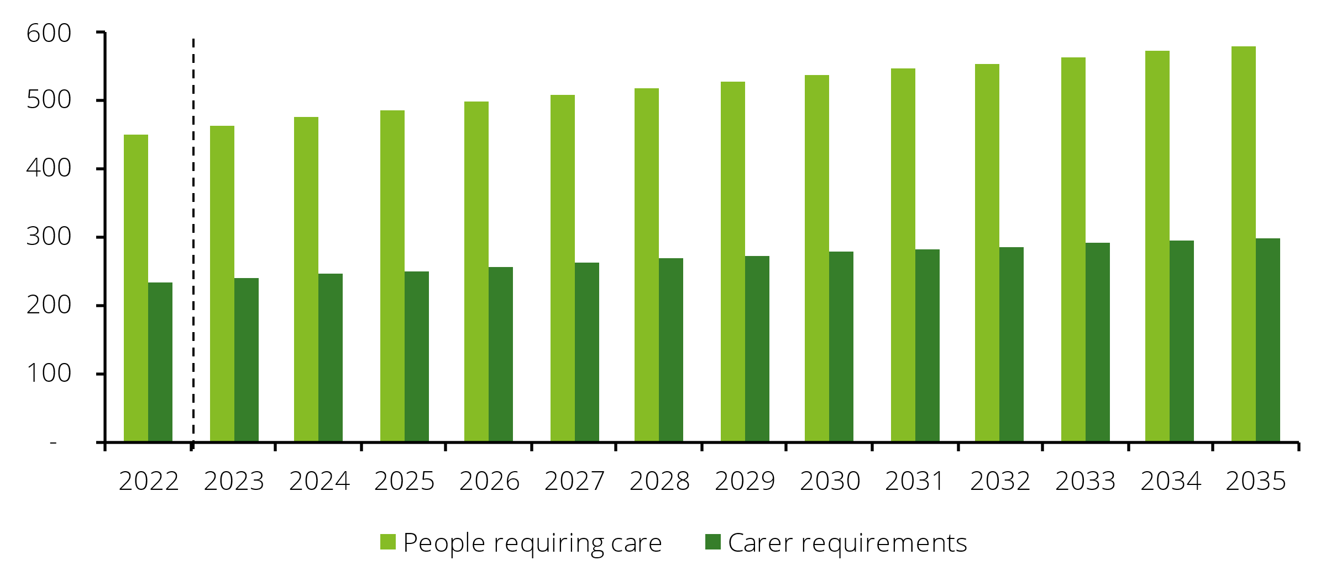Source: SDAC 2022, ABS population projections 2024, Deloitte Access Economics.

Forecast

Table 4.2: Projected number and growth of individuals requiring care and carer requirement in Queensland

|  |  |  |  |  |
| --- | --- | --- | --- | --- |
| **Component** | **2022** | **2030** | **2035** | **Growth (2022-2035)** |
| Individuals requiring care in Queensland | 450,000 | 540,000 | 580,000 | 130,000 |
| Primary informal carer requirement | 230,000 | 280,000 | 300,000 | 70,000 |

Source: SDAC 2022, ABS population projections 2024, Deloitte Access Economics.

An increasing share of the Queensland population taking on an informal caring role has broad implications for the economy and society. As illustrated in Chapter 1, carers (particularly primary carers) are much less likely to participate in the labour market than non-carers. Carers also have poorer health outcomes in terms of stated levels of stress and lower levels of overall wellbeing. Carers are less financially and economically secure than non-carers and are more likely to receive income support payments. Growth in the share of the population likely to be exposed to these outcomes is critical for policymakers at both the federal and state level.

## Discussion

This analysis presents a simple, base case approach to estimating the growth in the number of people requiring informal care in Queensland and the associated carer requirement, based **purely on expected population and demographic changes over time**. However, it is acknowledged that there are a range of factors that may impact these projections, such as socio-economic trends or the direction of government policy towards carers and care recipients.

### Population and demographic trends

Queensland is facing an ageing population, with ABS projections estimating the number of Queenslanders over 65 will increase from approximately 1.0 million in 2025 (19% of the population) to 1.7 million (23% of the population) by 2055. The impact of population ageing is incorporated into this analysis. However, future changes in the expected rate of population ageing will impact the projected growth in the number of people requiring informal care, and the associated carer requirement in the following ways:

* a more pronounced ageing of the population may result in a larger number of people requiring care in Queensland, or more intensive support needs than is currently accounted for in the modelling.
* as individuals age, their ability to provide care may decrease over time, and they may require carer assistance themselves.

### Prevalence and intensity of profound or severe disabilities

Changes in the prevalence of profound and severe disabilities within the Queensland population would impact the forecast of the individuals that may require care and the subsequent carer requirement. This analysis assumes that the prevalence of profound and severe disability within age- and gender-groups is held constant. However, there is evidence of a long-term downward trend in prevalence rates of disability in Australia, declining steadily from 20.0% in 2003 to 17.7% in 2018. However, more recently Australia has seen this trend reverse, with the prevalence rate of disability jumping to 21.4% in 2022, attributed to the health impacts of the COVID-19 pandemic.[30],[31] At this stage, it is not clear whether the growth in prevalence rates of disability experienced after the pandemic is an anomaly or the emergence of a new trend.

The intensity or severity of disabilities may also impact the care requirement. For example, if health conditions become increasingly complex and more severely limit a care recipient’s core activities, then the care requirement per individual receiving care would increase, meaning that a care recipient may require care from more individuals or more hours per carer.

### Size and scope of the formal care sector

The size, scope and accessibility of the formal care sector has an impact on the informal carer requirement in Queensland. The federal government provides a range of subsided formal community aged care programs, including the Commonwealth Home Support Program and the Home Care Packages Program. In addition to community care, residential aged care has become an increasingly common option for people who have become frail with age and require individualised attention.

However, gaining access to formal care services can be challenging due to the significant costs, substantial waiting lists and the length of time required to obtain home care packages and residential care individuals require. Reducing the barriers to the formal care sector may reduce the requirements of informal carers in Queensland as a result.

### Social and economic factors impacting the hours of care a carer can provide

Providing care can often involve significant time and commitment. The number of hours that carers spend caring is largely determined by the needs of the person receiving care, but social and economic factors may also have an impact. The hours of care per carer has implications for the carer requirement in Queensland. For example, if carers provide fewer hours of care then, all else equal, more carers would be required to meet a given level of demand.

The amount of care that carers provide could be impacted by:

* **Labour market participation:** the participation of informal carers in the labour market has increased over time. This reflects several factors, such as the rollout of the NDIS, the proliferation of work-from-home practices, a strong labour market and increasing costs of living. It is important that carers receive adequate support to enable them to work alongside their caring responsibilities. However, individuals may have to reduce the hours of care they provide due to an increasing need or desire to work. This could particularly apply for female carers, who are not only participating in the labour force at an increasing rate, but also represent the majority of informal carers (see Chart 1.3). Increased employment opportunities for females of working age could lead to more women choosing to work and may cause some to reduce the number of hours of care provided.
* **Cost of living:** increased living costs may increase the need for carers to participate in the labour market, as it increases their own costs and the costs of caring for another person, such as groceries, fuel and energy.
* **Changing gender norms:** historically, more women have taken on caring responsibilities, in part due to societal expectations about gender roles. It is unclear whether gender norms are changing in this regard. However, if they were to change, this has the potential to impact the hours of care that are provided. As outlined in Section 1.2.1, caring responsibilities currently fall more heavily on female carers during working age, with female carers tending to provide significantly more hours of care per week than male carers.
* **Family and societal norms:** the provision of informal care is also dependent on societal structure. Whether a person provides care to another, and how much care they provide, relies on the social context, particularly within families.[32] Family is critical to the provision of informal care, with 91.5% of primary informal carers being an immediate family member of the recipient in 2022.30 As a result, changes in how families are structured and how they live together could have a significant impact on how individuals care for each other going forward. Decreasing marriage rates, increasing divorce rates combined with lower fertility rates mean that Australian families are getting smaller. Alongside this, the number of Australians living alone is increasing. It is estimated that between 3.4 million and 4.0 million Australians will be living alone by 2046, up from 2.6 million in 2021.[33] Smaller families could reduce the number of people available to provide informal care, potentially increasing pressure on the formal care sector as well as increasing the carer requirement in terms of hours of care provided.

## Policy implications

Deloitte Access Economics finds that to maintain the same level and nature of informal care per person requiring care, the number of primary informal carers would be required to **increase from approximately 230,000 to 300,000** between 2022 and 2035. An increase in the carer requirement of this magnitude could have broad implications for Queensland:

### Health and social services sector

The ongoing deficit of informal carers will present some significant challenges for the management of Australia’s health and welfare over the next decade, particularly as the population continues to age. If left unaddressed, the misalignment of demand for and supply of care may place additional strain on the formal health and social services sector and could lead to poorer health outcomes for those who are unable to access care in the formal sector.

At the same time, a higher number (and population share) of carers could also increase demand for health and mental health services from carers themselves, with many carers reporting high levels of stress and low levels of wellbeing.

### Labour market, economic and fiscal outcomes

An increase in the number of primary informal carers required to maintain the same level of informal care per person would have an impact on the labour market and the productive capacity of Queensland. By 2035, approximately 4.7% (300,000) of Queenslanders are expected to be providing primary informal care, up from 4.3% (230,000) in 2022.30 With around half of primary carers currently not participating in the labour market, even small increases in the share of the population who are primary carers could impact the productive capacity and economic output per person in the state. It would also increase the cost to the government in terms of income support payments and forgone tax revenues.

At the individual level, reducing hours or stepping away from the workforce to fulfil caring responsibilities would result in foregone income.

### Support for carers

Chapter 3 of this report provides an overview of the current services available to carers in Queensland utilising the 2024 National Carer Survey to identify where gaps in services for informal carers exist. An increasing number (and population share) of primary informal carers required to maintain the current level of care underscores the need for Queensland to maintain a strong focus on providing support for informal carers and the requirement for effective collaboration between state and federal governments, healthcare providers and community organisations.

While a range of services are available to carers across the state, existing resources could become overextended if a larger number of individuals need to access support. Without effective collaboration between government agencies, service providers and carers themselves, the gaps in support for carers could widen or new ones could emerge. The likelihood and consequences of this occurring are uncertain, but a widening of gaps in support could detrimentally affect carers’ wellbeing and financial stability, possibly due to reduced working hours or leaving employment entirely. Limited access to respite care could further diminish carers' ability to recharge, affecting their health and the quality of care they provide. Consequently, care recipients might receive less consistent and lower-quality care, impacting their overall wellbeing and potentially leading to greater reliance on formal healthcare services.

A well-integrated support system will not only benefit carers but may also alleviate pressure on the formal healthcare sector by reducing hospital admissions or preventing carer burnout. By fostering a strategic and coordinated partnership between all levels of government, Queensland can build a sustainable support network that acknowledges the invaluable role of informal carers while ensuring they receive the recognition and assistance they deserve.

Appendix A: Replacement cost valuation methodology

## Total hours of care

Data from SDAC on the weekly hours of care provided is reported in bands, making it necessary to impute the average number of hours of care provided per week. The SDAC also only collects this data on those classified as primary or secondary carers, meaning that no data was available to impute the average weekly hours of care provided by carers who are neither primary nor secondary carers. These carers fit under the classification of non-primary carers within this report. Therefore, this group was assumed to spend an average of five hours per week providing care irrespective of the level of disability of the recipients. The imputed averages for primary and secondary carers are presented below and are used for valuation purposes throughout this section.

Table A.1: Average hours of care provided per week for primary and secondary carers

|  |  |
| --- | --- |
| **SDAC band (hours of care)** | **Imputed average (hours)** |
| 1-9 | 5 |
| 10-19 | 14.5 |
| 20-29 | 24.5 |
| 30-39 | 34.5 |
| 40-59 | 49.5 |
| 60+ | 65 |

Source: SDAC 2022, Deloitte Access Economics.

Table A.2 illustrates the share of primary and secondary carers who provide average weekly hours of care within the bands outlined above. As mentioned, carers who are neither primary nor secondary carers are assumed to provide an average of 5 hours of care per week.

Table A.2: Distribution of weekly hours of care by carer type

|  |  |  |  |
| --- | --- | --- | --- |
| **Imputed average (hours)** | **Primary carers** | **Secondary carers** | **Other carers** |
| 5 | 41% | 71% | 100% |
| 14.5 | 13% | 15% | 0% |
| 24.5 | 10% | 10% | 0% |
| 34.5 | 7% | 0% | 0% |
| 49.5 | 7% | 0% | 0% |
| 65 | 23% | 4% | 0% |

Source: SDAC 2022, Deloitte Access Economics.

The above shares are then multiplied by the total number of carers presented in section 1.2. The total number of non-primary carers (402,000) is split by secondary carers (79,000) and other carers (323,000) for the purpose of this calculation. This step was undertaken as cross tabulating the average weekly of hours of care provided by carer type using the SDAC creates data suppression issues, where the aggregate number of carers is below the aggregate number presented in section 1.2. This result provides the total number of carers by carer type providing each imputed average number of hours of care.

The above result was then multiplied by the imputed average weekly hours of care provided to obtain the total number of hours of care provided per week by carer type. This result was then adjusted to an annual basis. The results are presented below.

Table A.3: Total hours of care provided by carer type

|  |  |  |  |
| --- | --- | --- | --- |
|  | **Primary carers** | **Secondary carers** | **Other carers** |
| Total weekly hours of care | 6,837,916 | 850,761 | 1,615,000 |
| Average weekly hours of care | 26.8 | 10.8 | 5 |
| Total annual hours of care | 355,571,635 | 44,239,596 | 83,980,000 |

Source: SDAC 2022, Deloitte Access Economics.

From this, it is estimated that informal carers in Queensland spent approximately 484 million hours providing care in 2022.

## Wage estimate

The replacement value of informal care provided by carers is estimated by multiplying the total hours spent caring by the estimated average wage rate for carers in the formal sector. For this analysis, the average hourly wage for formal sector carers was derived in accordance with the Australian and New Zealand Standard Classification of Occupations (ANZSCO). Within the ANZSCO classifications, this analysis looked at the weighted mean of hourly ordinary time cash earnings of full-time Personal Carers and Assistants (ANZSCO 423). In May 2023, the average wage for this occupation was $38.50 per hour, or $1,444 for a 37.5-hour week. This is before deductions are made for tax and includes superannuation contributions and payment of overtime for after-hours work.

However, the wage received by carers does not reflect the whole cost associated with their employment. On-costs such as the wage for supervisors, managers or administrative support staff and other capital overheads are also incurred. To account for these additional costs, loadings for on-costs have been calculated. This was done by firstly estimating a total earnings figure inclusive of superannuation for workers in Queensland based on weekly cash earnings data. Additional labour costs were then calculated as a share of this total earnings figure, using labour cost estimates from the ABS.[34] These costs include payroll tax, workers compensation and fringe benefits. Adjustments were also made for the wage growth expected between May 2023 and December 2024, which was taken as the growth rate for wages in the health care and social assistance industry between June 2023 and December 2024.[35] Finally, loadings for capital and administrative overheads were based on the relative share of capital expenditure and administrative costs to other areas of recurrent spending in Australia’s formal health sector.[36]

Table A.4 below presents the base wage rate for Personal Carers and Assistants, as well as the loadings applied to arrive at the final hourly rate used for estimating the cost of replacing informal care. When these loadings are added, the average hourly cost of employing a formal carer to replace an informal carer is estimated to be $46.51 per hour, or $1,744 for a 37.5-hour week.

Table A.4: Replacement valuation of informal care, unit cost component

|  |  |  |
| --- | --- | --- |
| **Component** | **Loading** | **Hourly rate** |
| Hourly rate including overheads – May 2023 |  | $38.50 |
| Loading for wage growth – May 2023 to December 2024 | 7.36% | $2.83 |
| Loading for on-costs (payroll tax, workers compensation, fringe benefits) | 4.24% | $1.63 |
| Loading for capital | 6.24% | $2.40 |
| Loading for administration & supervision | 2.96% | $1.14 |
| **Total hourly rate including overheads – December 2024** |  | **$46.51** |

Source: Deloitte Access Economics using data from ABS Earnings and Hours survey (2023).

## Results

Multiplying the above wage estimate by the total number of hours of care provided by informal carers in Queensland yields a total replacement cost of approximately $22.5 billion.

Appendix B: Service gap costing methodology

## Unit cost of Carer Gateway services

The 2024 Impact Evaluation of the Integrated Carer Support Service states that the total cost of Carer Gateway is approximately $130 million. The evaluation also provides information on the number of services provided within each service type in 2022 (see Table B.1).

The evaluation categorises services as ‘low’ or ‘high’ cost based on the assumption that the difference between low and high costs are sufficiently large (e.g. more than 20% or 30%). Information, intake assessment and service review were classified separately as ‘common services’, but for the purpose of this report they are categorised as low-cost services as there is no information provided on the cost of common services.

Table B.1: Number of services provided by Carer Gateway, 2022

|  |  |  |
| --- | --- | --- |
| **Service type** | **Service cost** | **Number of services provided** |
| Carer support | High | 6,177 |
| Carer counselling | Low | 54,884 |
| Education and skills | Low | 18,986 |
| Emergency respite | High | 39,323 |
| Information | Low | 173,088 |
| Intake assessment | Low | 166,279 |
| Material goods | High | 2,910 |
| Mentoring | Low | 41,634 |
| Respite | High | 85,617 |
| Service review | Low | 48,733 |
| Specialist support | High | 47,089 |
| **Total** |  | **684,720** |

Source: 2024 Impact Evaluation of the Integrated Carer Support Service.

The table above illustrates that there were 684,720 services provided by Carer Gateway in 2022 consisting of 181,166 high-cost services and 503,604 low-cost services. Assuming that high-cost services cost 30% more than low-cost services, dividing the total cost of Carer Gateway by the number of services provided yields a unit cost of $228.67 for high-cost services and $175.90 for low-cost services.

The service types used in the 2024 NCS (which were used for the purpose of identifying service gaps) have been categorised by service cost by approximately matching these services with the service categories presented in the evaluation of Carer Gateway (see Table B.2). The number of carers in Queensland with unmet needs for each service type was then calculated by multiplying the share with unmet needs (from the 2024 NCS) by the total number of carers in Queensland. The cost to provide an additional unit of service for people with unmet needs was then calculated by multiplying the number of carers with unmet needs by the unit cost of services depending on whether the service type was categorised as low- or high-cost.

From this, providing an additional unit of support for carers with unmet needs in Queensland would cost approximately $380 million and would equate to almost two million additional services delivered across the state.

Table B.2: Cost to provide one additional unit of support for carers indicating an unmet need

|  |  |  |  |  |
| --- | --- | --- | --- | --- |
| **Service type** | **Service cost** | **Unmet needs** | **Number of carers in QLD with unmet needs** | **Cost to provide 1 unit of service for people with unmet need** |
| Emergency respite | High | 46% | 301,950 | 69,046,970 |
| Planned respite | High | 44% | 290,447 | 66,416,609 |
| Carer counselling | Low | 43% | 283,258 | 49,825,103 |
| Carer coaching | Low | 43% | 283,258 | 49,825,103 |
| Carer skills training | Low | 43% | 281,820 | 49,572,18 |
| Carer peer support online | Low | 42% | 277,506 | 48,813,426 |
| Carer support groups | Low | 40% | 266,003 | 46,790,071 |
|  |  |  | **1,984,241** | **$380,289,465** |

Source: Deloitte Access Economics using data from the 2024 Impact Evaluation of the Integrated Carer Support Service.

Appendix C: Unmet service needs for carers

Table C.1: Detailed unmet needs for informal carers by demographic characteristics

|  |  |  |  |  |  |  |  |  |
| --- | --- | --- | --- | --- | --- | --- | --- | --- |
| **Service Category** | **All respondents** | **Female** | **Male** | **Aged 15-64** | **Aged 65+** | **First Nations\*** | **CALD\*** | **In paid work** |
| **Emergency respite** |  |  |  |  |  |  |  |  |
| Used, unmet need | 0% | 1% | 0% | 0% | 1% | 0% | 4% | 1% |
| Not used, unmet need | 46% | 46% | 47% | 51% | 29% | 59% | 50% | 51% |
| **Planned respite** |  |  |  |  |  |  |  |  |
| Used, unmet need | 0% | 1% | 0% | 0% | 1% | 0% | 0% | 0% |
| Not used, unmet need | 44% | 43% | 50% | 50% | 28% | 59% | 50% | 51% |
| **Carer counselling** |  |  |  |  |  |  |  |  |
| Used, unmet need | 7% | 7% | 8% | 7% | 8% | 5% | 8% | 5% |
| Not used, unmet need | 36% | 36% | 33% | 40% | 25% | 36% | 38% | 44% |
| **Carer coaching** |  |  |  |  |  |  |  |  |
| Used, unmet need | 2% | 2% | 0% | 1% | 2% | 0% | 0% | 1% |
| Not used, unmet need | 42% | 42% | 42% | 46% | 31% | 41% | 46% | 48% |
| **Carer skills training** |  |  |  |  |  |  |  |  |
| Used, unmet need | 0% | 0% | 0% | 0% | 1% | 0% | 0% | 0% |
| Not used, unmet need | 43% | 43% | 42% | 47% | 29% | 59% | 48% | 49% |
| **Carer peer support online** |  |  |  |  |  |  |  |  |
| Used, unmet need | 1% | 1% | 0% | 1% | 1% | 0% | 0% | 0% |
| Not used, unmet need | 41% | 41% | 40% | 46% | 28% | 41% | 52% | 49% |
| **Carer support groups** |  |  |  |  |  |  |  |  |
| Used, unmet need | 2% | 2% | 2% | 3% | 1% | 0% | 0% | 0% |
| Not used, unmet need | 38% | 39% | 30% | 43% | 26% | 36% | 48% | 46% |

Source: Deloitte Access Economics using data from the 2024 National Carer Survey.

*Fewer than 50 survey respondents. CALD stands for Culturally and Linguistically Diverse.

Appendix D: Accessibility tables

This appendix includes summary tables describing the underlying data of key charts.

## Chapter 1

This section presents charts from Chapter 1.

Table D.1: Growth in the number of carers and demand for care, 2015-2022 – Chart 1.2

|  |  |  |  |
| --- | --- | --- | --- |
| **Region** | **Carers** | **People with disability** | **People aged over 60** |
| Queensland | 39% | 28% | 27% |
| Australian Capital Territory | 36% | 36% | 27% |
| Western Australia | 29% | 30% | 27% |
| Northern Territory | 16% | 23% | 19% |
| Australia | 13% | 21% | 21% |
| Tasmania | 8% | 22% | 24% |
| New South Wales | 6% | 14% | 17% |
| Victoria | 3% | 23% | 21% |
| South Australia | -2% | 14% | 20% |

Source: SDAC 2015, SDAC 2022, Deloitte Access Economics.

Table D.2: Age distribution of informal carers over time, 2009-2022 – Chart 1.6

|  |  |  |  |
| --- | --- | --- | --- |
| **Age bracket** | **2009** | **2015** | **2022** |
| Under 15 years old | 4% | 2% | 2% |
| 15-24 years old | 8% | 7% | 11% |
| 25-34 years old | 10% | 10% | 10% |
| 35-44 years old | 17% | 16% | 15% |
| 45-54 years old | 22% | 22% | 20% |
| 55-64 years old | 20% | 18% | 20% |
| 65-74 years old | 13% | 17% | 13% |
| 75 and older | 7% | 8% | 10% |

Source: SDAC 2009, SDAC 2015, SDAC 2022, Deloitte Access Economics.

Table D.3: Average hours of care provided per week by disability status, 2022 – Chart 1.9

|  |  |  |  |  |
| --- | --- | --- | --- | --- |
| **Average hours of care provided per week** | **Profoundly limited** | **Severely limited** | **Moderately limited** | **Mildly limited** |
| 1-9 hours | 16% | 61% | 100% | 100% |
| 10-19 hours | 14% | 8% | 0% | 0% |
| 20-29 hours | 11% | 10% | 0% | 0% |
| 30-39 hours | 9% | 6% | 0% | 0% |
| 40-59 hours | 12% | 3% | 0% | 0% |
| 60 hours or more | 37% | 14% | 0% | 0% |

Source: SDAC 2022, Deloitte Access Economics.

Table D.4: Employment status of informal carers by carer type, 2022 – Chart 1.11

|  |  |  |  |
| --- | --- | --- | --- |
| **Employment status** | **Primary carers** | **Non-primary carers** | **Non-carers** |
| Employed full-time | 26% | 42% | 46% |
| Employed part-time | 26% | 23% | 22% |
| NILF | 46% | 33% | 30% |
| Non-carers | 1% | 2% | 2% |

Source: SDAC 2022, Deloitte Access Economics.

Table D.5: Participation rate of informal carers over time, 2015-2022 – Chart 1.12

|  |  |  |  |
| --- | --- | --- | --- |
| **Year** | **Employment status** | **Primary carers** | **Non-primary carers** |
| 2015 | Employed full-time | 16% | 37% |
| 2018 | Employed full-time | 22% | 36% |
| 2022 | Employed full-time | 26% | 42% |
| 2015 | Employed part-time | 23% | 21% |
| 2018 | Employed part-time | 20% | 20% |
| 2022 | Employed part-time | 26% | 23% |
| 2015 | Unemployed | 3% | 5% |
| 2018 | Unemployed | 3% | 3% |
| 2022 | Unemployed | 1% | 2% |

Source: SDAC 2015, SDAC 2018, SDAC 2022, Deloitte Access Economics.

Table D.6: Income distribution by carer type, 2022 – Chart 1.13

|  |  |  |  |
| --- | --- | --- | --- |
| **Income distribution** | **Primary carers** | **Non-primary carers** | **Non-carers** |
| 1st quintile | 13% | 17% | 19% |
| 2nd quintile | 35% | 24% | 20% |
| 3rd quintile | 25% | 20% | 21% |
| 4th quintile | 17% | 24% | 21% |
| 5th quintile | 10% | 15% | 19% |

Source: SDAC 2022, Deloitte Access Economics.

Table D.7: Main source of income by carer type, 2022 – Chart 1.14

|  |  |  |  |
| --- | --- | --- | --- |
| **Main source of income** | **Primary carers** | **Non-primary carers** | **Non-carers** |
| Employee income | 52% | 69% | 78% |
| Government pensions and allowances | 37% | 22% | 14% |
| Superannuation pensions and annuities | 8% | 5% | 4% |
| Other income | 4% | 4% | 5% |

Source: SDAC 2022, Deloitte Access Economics.

Table D.8: Age and gender of main care recipient, 2022 – Chart 1.17

|  |  |  |
| --- | --- | --- |
| **Age of main care recipient** | **Male** | **Female** |
| 0-14 years old | 10% | 5% |
| 15-64 years old | 17% | 21% |
| 65 and older | 20% | 26% |

Source: SDAC 2022, Deloitte Access Economics.

Table D.9: Disability status of main care recipients, 2022 – Chart 1.18

|  |  |
| --- | --- |
| **Disability status** |  |
| Profoundly restricted | 52% |
| Severely restricted | 44% |
| Moderately restricted | 2% |
| Mildly restricted | 1% |
| Other | 1% |

Source: SDAC 2022, Deloitte Access Economics.

Table D.10: Relationship of primary carers to their main recipient of care, 2022 – Chart 1.19

|  |  |
| --- | --- |
| **Relationship of primary carer to their main recipient of care** |  |
| Partner | 38% |
| Parent | 30% |
| Child | 24% |
| Other | 9% |

Source: SDAC 2022, Deloitte Access Economics.

Limitation of our work

General use restriction

This report is prepared solely for the use of the Department of Families, Seniors, Disability Services and Child Safety of the State government of Queensland. This report is not intended to and should not be used or relied upon by anyone else and we accept no duty of care to any other person or entity. The report has been prepared for the purpose set out in the contract dated 6th February 2025. You should not refer to or use our name or the advice for any other purpose.



|  |
| --- |
| Deloitte Access Economics Pty Ltd  8 Brindabella Circuit  Brindabella Business Park  Canberra ACT 2609  Phone: +61 2 6263 700  Fax: +61 2 6263 7044  www.deloitte.com.au  Deloitte Access Economics is Australia’s pre-eminent economics advisory practice and a member of Deloitte's global economics group. For more information, please visit our website: [www.deloitte.com/au/deloitte-access-economics](http://www.deloitte.com/au/deloitte-access-economics)  Deloitte refers to one or more of Deloitte Touche Tohmatsu Limited (“DTTL”), its global network of member firms, and their related entities (collectively, the “Deloitte organization”). DTTL (also referred to as “Deloitte Global”) and each of its member firms and related entities are legally separate and independent entities, which cannot obligate or bind each other in respect of third parties. DTTL and each DTTL member firm and related entity is liable only for its own acts and omissions, and not those of each other. DTTL does not provide services to clients. Please see www.deloitte.com/about to learn more.  Deloitte Asia Pacific Limited is a company limited by guarantee and a member firm of DTTL. Members of Deloitte Asia Pacific Limited and their related entities, each of which is a separate and independent legal entity, provide services from more than 100 cities across the region, including Auckland, Bangkok, Beijing, Bengaluru, Hanoi, Hong Kong, Jakarta, Kuala Lumpur, Manila, Melbourne, Mumbai, New Delhi, Osaka, Seoul, Shanghai, Singapore, Sydney, Taipei and Tokyo.  This communication contains general information only, and none of DTTL, its global network of member firms or their related entities is, by means of this communication, rendering professional advice or services. Before making any decision or taking any action that may affect your finances or your business, you should consult a qualified professional adviser.    No representations, warranties or undertakings (express or implied) are given as to the accuracy or completeness of the information in this communication, and none of DTTL, its member firms, related entities, employees or agents shall be liable or responsible for any loss or damage whatsoever arising directly or indirectly in connection with any person relying on this communication.   Liability limited by a scheme approved under Professional Standards Legislation.   Member of Deloitte Asia Pacific Limited and the Deloitte organisation.  © 2025 Deloitte Touche Tohmatsu. true |

1. This report calculates the total number of informal carers using SDAC 2022 (accessed via Tablebuilder in February 2025), disaggregated by State or Territory of usual residence by Carer Status. There is some uncertainty around the number of informal carers aged under 15 in Queensland. According to the SDAC, there are approximately 13,000 informal carers aged under 15 in Queensland. If this is removed from the total number of carers it can be assumed that there are at least 644,000 informal carers in Queensland.
2. Replacement cost estimates do not include forgone superannuation investment returns that would accrue to the carer.
3. Carers NSW, *2024* *National Carer Survey* (2024).
4. Carers Australia, *Who is a Carer?* (n.d.); ABS, *Disability, Ageing and Carers, Australia: Summary of Findings* (4 July 2024).
5. Triantafillou et al*., Informal care in the long-term care system* (March 2011).
6. The Australian Bureau of Statistics’ (ABS) Survey of Disability, Ageing and Carers (SDAC) is the most comprehensive profile of people receiving care and their carers in Australia. This national survey covers people living in private dwellings in urban and rural areas. People living in non-private dwellings – including care accommodation such as nursing homes, hostels and other facilities – are also within the scope of this survey. Definitions of type of carer follow those provided by SDAC.
7. Disability status refers to SDAC’s definition, categorising care recipients by their ability to carry out ‘core activities’. Core activities include communication, mobility and self-care.
8. NILF stands for ‘not in the labour force’.
9. The participation rate is calculated as the proportion of working-age individuals who are either employed or are actively seeking employment.
10. Australian Bureau of Statistics, *Australian National Accounts: Distribution of Household Income, Consumption and Wealth 2021-22* (13 December 2022).
11. Australian Government Department of Social Services, *National Carer Strategy 2024-2034* (10 December 2024).
12. ‘Non-heterosexual’ refers to individuals who identify as gay, lesbian, bisexual or a different term.
13. Ehrlich, Emami & Heikkilä, *The relationship between geographical and social space and approaches to care among rural and urban caregivers caring for a family member with Dementia: a qualitative study* (December 2017).
14. This method of valuation is different to an economic impact assessment and therefore does not consider the wider costs and benefits associated with the informal care sector becoming formal, such as increased expenditure through higher incomes and decreased government spending through reduced carer payments.

    It also does not consider whether the wage adequately reflects the value provided by the formal care sector or the intangible benefits associated with informal care that would not accrue if it were replaced by the formal sector.
15. Australian Bureau of Statistics, *Australian National Accounts: National Income, Expenditure and Product* (5 March 2025).
16. The replacement cost methodology in this report differs slightly from Deloitte Access Economics’ *The value of informal care in 2020* report*.* As such, the replacement costs cannot be directly compared.
17. Australian Bureau of Statistics, *National, state and territory population* (20 March 2025).
18. Deloitte Access Economics, *The value of informal care in 2020* (May 2020).
19. The wage of formal carers used the wage of the Personal Carers and Assistants occupation. Please refer to Appendix A for further detail.
20. For example, the National Aged Care Workforce Census and Survey 2016 found the national average ratio of direct care workers to operational places was 0.78, indicating that each carer was responsible for around 1.3 care recipients.
21. Fair Work Ombudsman, *Pay Calculator* (2025). Note: this analysis was conducted for individuals employed in the home care sector at employee level 2 – pay point 2.
22. NDIS, *Pricing Arrangements and Price Limits 2024-25* (1 October 2024). Note: for this analysis, the cap for providers delivering standard assistance with self-care activities during the daytime on a weekday was used.
23. A service may be available in multiple locations e.g. Brisbane and regional towns.
24. Needs are classified as ‘unmet’ if respondents have either used the service but still have ongoing needs, or if they have not used the service at all but require support.
25. UNSW Social Policy Research Centre, *Impact Evaluation of the Integrated Carer Support Service (Carer Gateway): Final Report* (March 2024).
26. It is assumed that high-cost services are 30% more costly than low-cost services, following the same approach as the UNSW Social Policy Research Centre.
27. However, providing additional services to carers may reduce the economic value they provide. For example, providing more respite care would reduce the time that informal carers spend providing care.
28. Australian Bureau of Statistics, *Population Projections, Australia* (23 November 2023).
29. The same analytical framework has been used to analyse the supply and demand for primary informal care. However, the approach used to estimate the demand and supply of carers in 2020 Carers Australia report has been modified for the purposes of this report. The 2020 report estimated both demand and supply of carers by applying population projections to estimates of the propensity to provide and receive primary informal care. Demand for carers represented the population of those with a severe disability who require daily care, whereas the supply of carers forecasts the supply of co-resident primary informal carers.
30. Australian Bureau of Statistics, *Disability, Ageing and Carers, Australia: Summary of Findings* (4 July 2024).
31. Australian Institute of Health and Welfare, *People with disability in Australia 2022* (2022).
32. Broese van Groenou & De Boer, *Providing informal care in a changing society* (15 April 2016).
33. Australian Bureau of Statistics, *Household and Family Projections, Australia (2021-2046)* (28 June 2024).
34. Australian Bureau of Statistics (ABS), *Labour Costs, Australia, 2015-16* (28 August 2017).
35. Australian Bureau of Statistics (ABS), *Wage Price Index, Australia* (19 February 2025).
36. Australian Institute of Health and Welfare (AIHW), *Health expenditure Australia 2022-23* (20 November 2024).