**Child Safety   
POLICY**

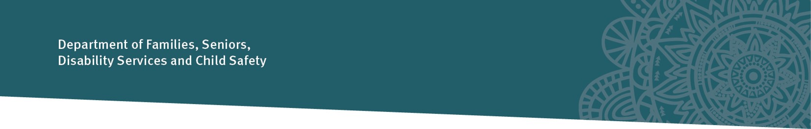

**Title:** Structured Decision Making

**Policy No:** 407-8

**Policy Statement:**

The Department of Families, Seniors, Disability Services and Child Safety (Child Safety) has a legislative responsibility to respond to information received about harm or risk of harm to a child, or an unborn child who may be at risk after he or she is born, and to take action to ensure the child’s safety when there is no parent able and willing to protect the child.

Child Safety staff will use Structured Decision Making, in conjunction with professional judgement and knowledge of legislation, policies and procedures, to facilitate decision-making at designated decision points across the child protection continuum.

Child Safety is committed to respecting, protecting and promoting human rights. The *Human Rights Act 2019* requires Child Safety to act and make decisions in a way that is compatible with human rights and, when making a decision, to give proper consideration to human rights.

The safe care and connection of Aboriginal and Torres Strait Islander children with family, community, culture and country will be a key consideration in decision making by Child Safety staff.

**Principles:**

* The safety, wellbeing and best interests of the child, both throughout childhood and the rest of the child’s life, are paramount.
* Every child has a right to protection from harm.
* Child Safety staff will act and make decisions in a way that is compatible with human rights and obligations under the *Human Rights Act 2019*.
* Consistent assessment and case planning enhance quality outcomes for children.
* The five elements of the Aboriginal and Torres Strait Islander Child Placement Principle (prevention, partnership, placement, participation and connection) under the *Child Protection Act 1999*, section 5C, apply to any processes, decisions and actions taken for an Aboriginal or Torres Strait Islander child.
* Increased accuracy of critical decisions contributes to the safety of children.



**Objectives:**



This policy aims to support Child Safety staff to make consistent, accurate and timely decisions that result in the delivery of high-quality child protection services to children and families.

**Scope:**

This policy and associated procedures refer to and guide the decisions and actions of Child Safety staff when applying one or more of the following Structured Decision Making assessment tools during child protection intervention:

* Safety assessment
* Child strengths and needs assessment
* Parental strengths and needs assessment.

**Roles and Responsibilities:**

The roles and responsibilities of Child Safety staff in relation to Structured Decision Making are outlined in the Child Safety Practice Manual and associated resources.

**Authority:**

*Child Protection Act 1999*, sections 7, 14, 21A, 51A - 51F, 51U - 51X, 73, 82.

**Delegations:**

Refer to instruments of delegation for delegations relevant to investigation and assessment decisions and case planning.

**Records File No.:** Not applicable

**Date of approval:** 29 October 2024

**Date of operation:** 10 April 2025

**Date to be reviewed:**  10 April 2027

**Office:** Office of the Chief Practitioner

**Help Contact:** Child Protection Practice

**Links:**

**Procedures**

Structured Decision Making Policy and Procedures Manual

Child Safety Practice Manual



**Related Legislation***Human Rights Act 2019*



**Forms**

Safety assessment

Parental strengths and needs assessment

Child strengths and needs assessment

**Rescinded Policy**

407-7 Structured Decision Making

Deidre Mulkerin   
Director-General

