# Family Participation Program

## Client Engagement Tool Fact Sheet (July 2025)

### What is the Client Engagement Tool?

The Client Engagement Tool (CET) is one way to engage with families that have been supported by the Family Participation Program (FPP).

It is a short anonymous survey which provides the Department of Families, Seniors, Disability Services and Child Safety with feedback directly from the participants about their experience and satisfaction with the program. Feedback provided by families can be very powerful and can demonstrate the need for the service.

The survey can be offered in two different modes:

1. Online through the link provided in this document. The link is service specific.
2. A paper-based survey, which has been provided as a PDF document to each service, and a reply-paid envelope to allow families to take away the survey and complete in the privacy of their own home.

There are four (4) sections in the survey seeking basic information:

1. Simple demographic information about the person completing the survey.
2. The family’s feelings about their experience with the FPP.
3. The family’s outcome from the FPP.
4. 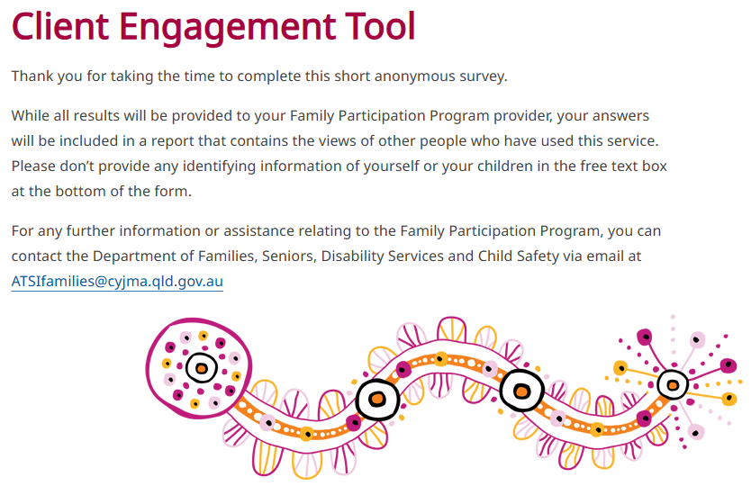A free text box for any additional information/feedback.

### Is the survey confidential?

Yes. The survey is completely confidential and is provided back to the Aboriginal and Torres Strait Islander Families team to collect the responses, either online or by post.

The survey does not ask for any identifying elements in the answer selections offered. The answers provided cannot identify them, the staff, or any persons involved in the FPP process unless this information is mentioned in the free text box.

Please ensure any family member that receives the survey is made aware to not provide their names or any details of the children involved.

## What do I tell my FPP participants?

The feedback provided will ensure effective and culturally safe practices are exercised when working with Aboriginal and Torres Strait Islander families. All feedback is important and valued and will ensure that this program is working well in the community and creating successful outcomes for Aboriginal and Torres Strait Islander families.

Participant answers will be provided to the Aboriginal and Torres Strait Islander Families team and the FPP in a report which may highlight:

* the participants involvement in the process
* the outcome of the process
* an opportunity for the participant to share their experience of the program.

It will let the department know how well they were supported during the FPP process.

## Contact

For any further information or assistance relating to the FPP, you can contact the department via email at [ATSIfamilies@cyjma.qld.gov.au](mailto:ATSIfamilies@cyjma.qld.gov.au)

## Client Engagement Tool – Provider Links

|  |
| --- |
| **Aboriginal and Islanders Development and Recreational Women's Association Mount Isa and District Inc.**  <https://www.families.qld.gov.au/our-work/child-safety/aboriginal-torres-strait-islander-families/family-participation-program/client-engagement-tool?id=471486> |
| **Aboriginal and Torres Strait Islander Community Health Service Brisbane - Brisbane**  <https://www.families.qld.gov.au/our-work/child-safety/aboriginal-torres-strait-islander-families/family-participation-program/client-engagement-tool?id=471484> |
| **Aboriginal and Torres Strait Islander Community Health Service Brisbane - Logan/Beenleigh/Browns Plains**  <https://www.families.qld.gov.au/our-work/child-safety/aboriginal-torres-strait-islander-families/family-participation-program/client-engagement-tool?id=471485> |
| **Central Queensland Indigenous Development Ltd - Rockhampton**  <https://www.families.qld.gov.au/our-work/child-safety/aboriginal-torres-strait-islander-families/family-participation-program/client-engagement-tool?id=471487> |
| **Central Queensland Indigenous Development Ltd - Wide Bay**  <https://www.families.qld.gov.au/our-work/child-safety/aboriginal-torres-strait-islander-families/family-participation-program/client-engagement-tool?id=471488> |
| **Cherbourg Regional Aboriginal and Islander Community Controlled Health Services Ltd (CRAICCHS)**  <https://www.families.qld.gov.au/our-work/child-safety/aboriginal-torres-strait-islander-families/family-participation-program/client-engagement-tool?id=471489> |
| **Goolburri Aboriginal Health Advancement Co Ltd**  <https://www.families.qld.gov.au/our-work/child-safety/aboriginal-torres-strait-islander-families/family-participation-program/client-engagement-tool?id=471490> |
| **Gungarde Community Centre Aboriginal Corporation**  <https://www.families.qld.gov.au/our-work/child-safety/aboriginal-torres-strait-islander-families/family-participation-program/client-engagement-tool?id=687313982> |
| **Kalwun Development Corporation - Beaudesert**  <https://www.families.qld.gov.au/our-work/child-safety/aboriginal-torres-strait-islander-families/family-participation-program/client-engagement-tool?id=797014906> |
| **Kalwun Development Corporation - Gold Coast**  <https://www.families.qld.gov.au/our-work/child-safety/aboriginal-torres-strait-islander-families/family-participation-program/client-engagement-tool?id=471492> |
| **Kambu Aboriginal and Torres Strait Islander Corporation for Health**  <https://www.families.qld.gov.au/our-work/child-safety/aboriginal-torres-strait-islander-families/family-participation-program/client-engagement-tool?id=471491> |
| **Kummara Limited**  [https://www.families.qld.gov.au/our-work/child-safety/aboriginal-torres-strait-islander-families/family-participation-program/client-engagement-tool?id=1416421447](https://aus01.safelinks.protection.outlook.com/?url=https%3A%2F%2Fwww.families.qld.gov.au%2Four-work%2Fchild-safety%2Faboriginal-torres-strait-islander-families%2Ffamily-participation-program%2Fclient-engagement-tool%3Fid%3D1416421447&data=05%7C02%7CLisa.Hurle%40dcssds.qld.gov.au%7C71343506ff854a96815208dd65cd6b0b%7C95b907c2752b485088ad86939ce522f0%7C0%7C0%7C638778655138579697%7CUnknown%7CTWFpbGZsb3d8eyJFbXB0eU1hcGkiOnRydWUsIlYiOiIwLjAuMDAwMCIsIlAiOiJXaW4zMiIsIkFOIjoiTWFpbCIsIldUIjoyfQ%3D%3D%7C0%7C%7C%7C&sdata=xXw1fqrTOyJgkHMvO0by4nKNcXTiAS5Ta9U59hBZyfE%3D&reserved=0) |
| **Marabisda Inc.**  <https://www.families.qld.gov.au/our-work/child-safety/aboriginal-torres-strait-islander-families/family-participation-program/client-engagement-tool?id=471493> |
| **Mura Kosker Sorority Inc.**  <https://www.families.qld.gov.au/our-work/child-safety/aboriginal-torres-strait-islander-families/family-participation-program/client-engagement-tool?id=471761> |
| **Palm Island Community Company**  <https://www.families.qld.gov.au/our-work/child-safety/aboriginal-torres-strait-islander-families/family-participation-program/client-engagement-tool?id=471495> |
| **Remote Area Aboriginal and Torres Strait Islander Child Care Advisory Association Inc (RAATSIC)**  <https://www.families.qld.gov.au/our-work/child-safety/aboriginal-torres-strait-islander-families/family-participation-program/client-engagement-tool?id=687213980> |
| **REFOCUS Aboriginal & Torres Strait Islander Limited - Moreton Bay**  <https://www.families.qld.gov.au/our-work/child-safety/aboriginal-torres-strait-islander-families/family-participation-program/client-engagement-tool?id=1314520064> |
| **REFOCUS Aboriginal & Torres Strait Islander Limited - Sunshine Coast and Gympie**  <https://www.families.qld.gov.au/our-work/child-safety/aboriginal-torres-strait-islander-families/family-participation-program/client-engagement-tool?id=471496> |
| **Townsville Aboriginal & Torres Strait Islander Health Service**  <https://www.families.qld.gov.au/our-work/child-safety/aboriginal-torres-strait-islander-families/family-participation-program/client-engagement-tool?id=471497> |
| **Wuchopperen Health Service Ltd**  <https://www.families.qld.gov.au/our-work/child-safety/aboriginal-torres-strait-islander-families/family-participation-program/client-engagement-tool?id=471498> |