Department of Families, Seniors, Disability Services and Child Safety
Information privacy
  - Information for carers
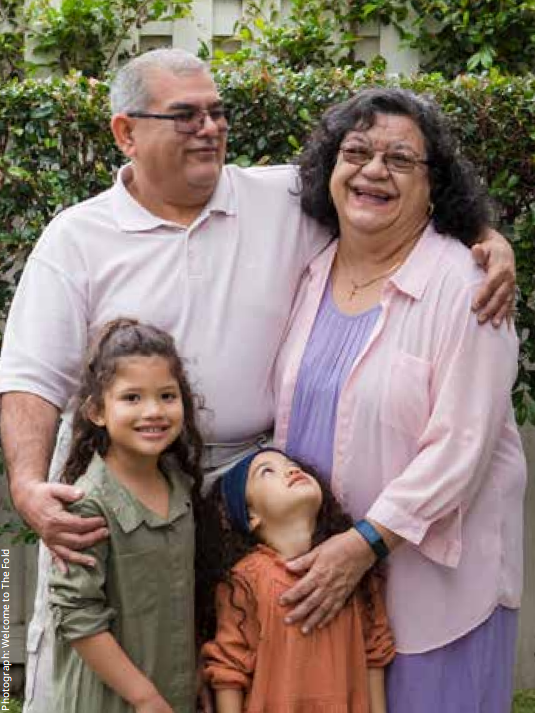

About your privacy
We are committed to protecting your privacy when we collect or handle your personal information.
The Information Privacy Act 2009 sets rules about how we collect and handle your personal information and limits how we can use and disclose it.

Personal and sensitive information
Personal information is information or opinion about an identifiable person, whether true or not.
Sensitive information is personal information about matters including racial or ethnic origin, religious beliefs or affiliations, sexual orientation, criminal record, or health information.

Do I have to identify myself?
You can remain anonymous or use a pseudonym when dealing with us, unless example:
• there is a law that says we must deal with identified individuals, or
• it is not practical to deal with people who have not identified themselves.
To be approved as a carer, you must identify yourself. However, you can make anonymous complaints or notifications of harm.

Collection
We collect personal information so we can do our job and protect children. The Child Protection Act 1999 allows us to collect this information.
If we need to collect sensitive information about you, we will usually ask for your consent. However, collection without consent may be authorised if, for example, we need it to:
• lessen or prevent a serious threat to life, health or safety
• take appropriate action in relation to unlawful activity or serious misconduct
• help locate a missing person.
We will not collect your information in a way that is unfair, unlawful or interferes with your privacy. We will only collect personal information from you, unless:
• you agree we can collect it from someone else
• we are required or allowed to collect it from someone else, or
• it is unreasonable or impractical to collect it from you.
When we collect your information, we will tell you:
• why we are collecting it
• why we are allowed to collect it
• the main consequences for you if it isn’t collected
• who we usually give it to
• whether it will be disclosed overseas
• how you can access and correct the information recorded about you, and
• how to make a privacy complaint.

Use and disclosure
We will only use or disclose your information for the purpose for which we collected it unless you agree, or an exception applies. For example, if:
• there is a law that says we can do so
• there is a serious threat to someone’s safety
• we are responding to unlawful activity or serious misconduct, or
• we need it to help find a missing person.
We use the information we collect to do our child protection work, including:
• assessing if a child needs protection
• assessing your suitability to be a carer
• case planning
• informing you about matters relevant to a child in your care
• applying for court orders.

Security
We take reasonable steps to protect your personal information and keep it safe. We take this obligation very seriously and we constantly work to improve security and ensure your information is protected.

Collection, use and disclosure of information
Further information about how we collect, use and disclose information is available on our website at:
www.families.qld.gov.au/privacypolicy

Access and correction
We have ‘administrative access schemes’ you may be able to use to get copies of your personal information.
You may also apply for your information under the Information Privacy Act 2009.
If your information is wrong, out of date, incomplete, irrelevant or misleading, you can ask us to correct our records.
Further information about these processes is available on our website at: www.families.qld.gov.au/righttoinformation

Complaints
If you think that we have not managed your personal information properly, you can make a complaint.
Further information about how to make a complaint is available on our website at:
www.families.qld.gov.au/complaints

Your obligations
Information you obtain through your role as a carer is confidential and you must only use or disclose it in accordance with the Child Protection Act 1999.
Unauthorised use or disclosure of child protection information is an offence and may be punishable by a fine or imprisonment.
If you are unsure whether you can use or share information you receive in your role as a carer, talk to your Child Safety Officer.

Further information
More information about your obligations is available at:

The above QR code links to website www.qld.gov.au/community/caring-child/foster-kinship-care/information-for-carers/rights-and-responsibilities/carers-responsibilities/privacy-confidentiality
Document version: 1209_NOV2025

