Department of Families, Seniors, Disability Services and Child Safety
Information privacy
Information for parents
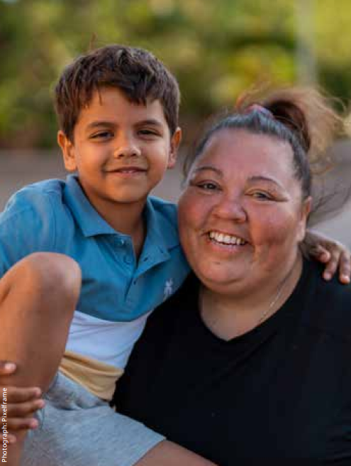

About your privacy
We are committed to protecting your privacy.
The Information Privacy Act 2009 sets rules about how we collect and handle your information and limits how we can use and disclose it.
Personal and sensitive information
Personal information is information or opinion that could identify you.
Sensitive information includes things like your racial or ethnic origin, religious beliefs, sexual orientation, criminal record, and health information.

Do I have to identify myself?

You can remain anonymous or use a pseudonym when dealing with us, unless for example:
- there is a law that says we must deal with identified individuals, or
- it is not practical to deal with people who have not identified themselves.
If we are working with you because of concerns about your child’s safety, we will need to know your name.

Collection
We collect personal information so we can do our job and protect children. The Child Protection Act 1999 allows us to collect this information.
If we need to collect sensitive information about you, we will usually ask for your consent.
However, we can collect sensitive information without your consent if, for example, we need it to:
- prevent a threat to someone’s safety
- prevent or respond to unlawful activity or serious misconduct, or
- help find a missing person.
We will not collect your information in a way that is unfair, unlawful or interferes with your privacy.
We will only collect personal information from you, unless:
- you agree we can collect it from someone else• there is a law that says that we can collect it from someone else, or
- it is unreasonable or impractical to collect it from you.
When we collect your information, we will tell you:
- why we are collecting it
- why we are allowed to collect it
- consequences if we don’t collect it
- who we usually give it to
- whether it will be disclosed overseas
- how you can access and correct the information we record about you, and
- how to make a privacy complaint.

Use and disclosure
We use the personal information we collect to do our child protection work, including:
- working out if a child needs protection
- working out what support you need
- case planning
- applying for court orders.
We might disclose information about you or your child to other people, for example:
- we tell carers about your child’s needs
- we tell the school information to help plan for your child’s schooling
- we tell the Court why we think an order should be made.
We will not use or disclose your information for any other purpose, unless:
- you agree to it
- there is a law that says we can
- there is a serious threat to someone’s safety
- we are responding to unlawful activity or serious misconduct, or
- we need it to help find a missing person.
Security
We take steps to protect your personal information and keep it safe.
We take this obligation very seriously and we constantly work to improve security and ensure your information is protected.

Access and correction
We have ‘administrative access schemes’ that you may be able to use to get copies of your personal information.
You may also apply for your information under the Right to Information Act 2009.
If you think the information is wrong, out of date, incomplete, irrelevant or misleading, you can ask us to correct our records.
Further information about these processes is available on our website at: www.families.qld.gov.au/righttoinformation
Your obligations
Information we share with you is confidential and you must only use or disclose it in accordance with the Child Protection Act 1999.
Unauthorised use or disclosure of child protection information is an offence and may be punishable by a fine or imprisonment.
If you are unsure whether you can use or share information that we share with you, talk to your Child Safety Officer.

Further information
More information about your obligations and how we collect, use and disclose personal information is available in our privacy policy and on our website at:
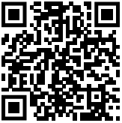
The above QR code links to website https://www.families.qld.gov.au/about-us/our-department/right-information/information-privacy
Document version: 1209_NOV2025

