Making active efforts

to keep Aboriginal and Torres Strait Islander children safe and connected to family, community and culture

Information for families

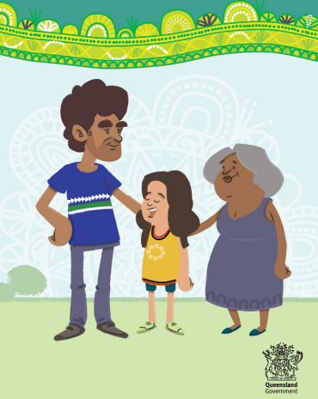

Sometimes, we need to work with families to make decision about how their children can be cared for safely.

If we’re working with our family, we must, by law, make active efforts to uphold your rights under the Aboriginal and Torres Strait Islander Child Placement Principle.

# What is the Aboriginal and Torres Strait Islander Child Placement Principle?

The Aboriginal and Torres Strait Islander Child Placement Principle recognises a child’s right to be connected to their family, community, culture and country.

It also recognises your right to take part when important decisions are being made about the care and safety of your child.

# The Aboriginal and Torres Strait Islander Child Placement Principle has five elements:

1. **Prevention** – a child has the right to be brought up in family and community
2. **Partnership** - Aboriginal and Torres Strait Islander peoples have the right to participate in making decisions about their child
3. **Participation** – a child, their parents and families have the right to take part in and be supported to take part in making important decisions about the child’s safety
4. **Placement** – a child has the right to be placed with a member of their family if they are placed in care
5. **Connection** – a child has the right to be connected to their family, community, culture, traditions and language, particular if the child is being care for by a person who is not an Aboriginal and Torres Strait Islander person.

# What are active efforts?

Active efforts mean when we are working with you, we must do everything it is practical to do, as soon as possible, to make sure your child is safe and stays connected to their family, culture and community.

We must also uphold your right to be involved when important decisions are being made.

We will make active efforts to:

* **respect and understand** your culture
* make sure you can **have your say**
* **listen** to what you say before we make decisions
* work with your local community-controlled organisations so your family gets the right **help at the right time**.

# Who can I talk to about active efforts?

If you feel we’re not making active efforts, you can talk to your Child Safety Officer about what we can do to help you.

If you still have worries after talking to your Child Safety Officer, you can talk to your Child Safety Service Centre Manager.

You can also call our Complaints Unit on 1800 080 464 (free call)

For more information

[www.qld.gov.au/making-active-efforts](http://www.qld.gov.au/making-active-efforts)

Queensland Government

Department of Child Safety

Publication ID 1036JUNE2023