Department of Families, Seniors, Disability Services and Child Safety
Information privacy
Information for young people
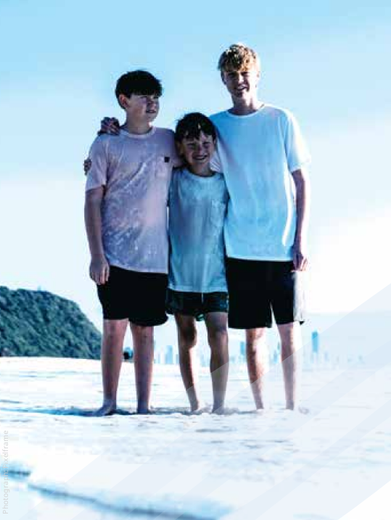

What is personal information?
Personal information is information about you and your family.
We collect your personal information to help us understand if your family needs support and to make sure you are cared for.
We are only allowed to collect your personal information to help us make decisions about your safety and wellbeing.
If you don’t understand why your Child Safety Officer wants to know certain things, you can ask them to explain why they need the information.
Sometimes, we may collect sensitive information about you. Sensitive information includes your ethnic origin, gender identity, health, and religious beliefs.
When we talk to you about any problems you may be having at home or in care, we will explain:
- the personal information we need
- how we use your personal information
- how we will keep it private
- who we may need to tell about it
- how you can see the personal information we collect about you.
We will always ask for your consent before we collect your personal or sensitive information, where possible.

What is information privacy?
When we collect your personal information, we must keep it private. There are laws to make sure the information we collect about you and your family is kept private.
We will do everything possible to protect your privacy when we collect or use your personal information.
We won’t collect your information in a way that is unfair or unlawful, or interferes with your privacy.
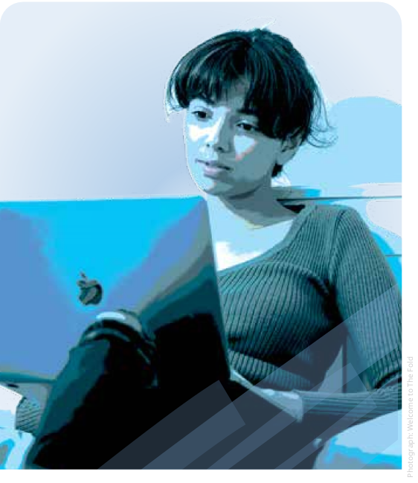

How is my personal information used?
We will only use your personal information for the reason we collected it.
Sometimes, we may need to use your personal information for other reasons. For example, if:
- it’s necessary to keep you safe and cared for
- the police need the information
- there is a law that says we can use the information.
We will ask for your consent before we use your personal information in these ways, where possible.
We may give your personal information to other people so we can:
- provide the right support to you and your family
- tell your carer things they need to know about how to care for you
- make sure you get the best health care or help at school
- prepare a case plan that sets out what everyone involved in y our care must do
- prepare for court matters so the court understands all the important things about keeping you safe and cared for.

Can I see my personal information?
Yes, there are laws that say you have the right to see the personal information we collect
about you.
If you think the personal information we have collected about you is wrong, you can ask us to change it.
You can talk to your Child Safety Officer about the changes you want us to make to your personal information.
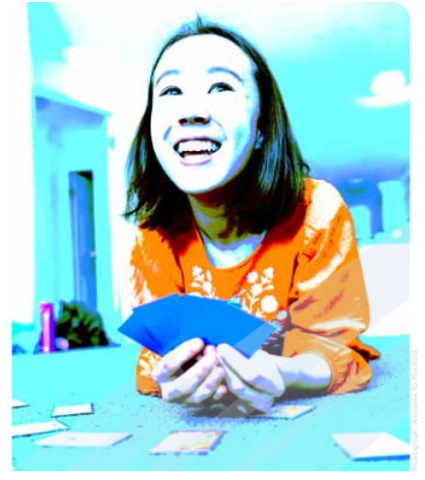

Can I make a complaint?
Yes. If you feel we have not been careful with your personal information, you can make a complaint.
You can talk to your Child Safety Officer or carer about how you feel.
You can also call us to make a complaint. Phone: 1800 080 464 (free call)
Further information is available on our website at: www.families.qld.gov.au/makeacomplaint

